CATHOLIC WORLD LAST WEEK
(CWLW)
15-21 May 2023
15-5-23
Pontiff reforms Vatican City State’s ‘constitution’
Pope Francis issued a new Legge Fondamentale (Fundamental Law) for Vatican City State. The 2023 “constitution” in the third in the state’s history, following the Lateran Treaty (1929) and a revision promulgated by Pope St. John Paul II (2000).
The revised Fundamental Law has more stringent financial reporting requirements and allows for the appointment of laity to the Pontifical Commission for Vatican City State, according to Vatican News. The revised Fundamental Law confirms that the Pontiff exercises “the fullness of legislative, executive, and judicial powers.”
Consider the countryside a gift from God, Pope tells young farmers
(15-5-23) Pope Francis received members of the Asociación Agraria de Jóvenes Agricultores [Agrarian Association of Young Farmers] on May 13.
“If you think about it, the vocation to which God has called you makes you witnesses to an integral ecology that the world needs today,” the Pope said. God “asks you to think of the countryside as a gift, as something that has been given to you and that you will bequeath to your children; to think of production as a gift that the Lord, through you, and through your work, sends to his people to satiate their hunger and quench their thirst.”
The Pope told the farmers that “it is necessary to work so that this immense good that God gives us is not transformed into a weapon —for example, by restricting the arrival of food to populations in conflict —or into a mechanism of speculation, manipulating the price and marketing of products for the sole purpose of obtaining a greater benefit.”
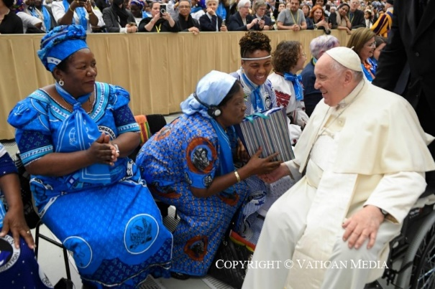
Look to Mary, cultivate prayer and communion with the Church: papal call to Catholic women’s organizations
(15-5-23) On May 13, Pope Francis received participants in the general assembly of the World Union of Catholic Women’s Organizations.
The Pope called on the participants to “listen to the lament of so many women in the world who suffer injustice, abandonment, discrimination, poverty, or inhuman treatment since childhood in some cases.” The audience took place on the memorial of Our Lady of Fátima, and during his address, Pope Francis reflected on the Fátima apparitions.
Chief Rabbinate of Israel, Vatican issue joint statement condemning euthanasia, assisted suicide
(15-5-23) The Bilateral Commission of the Delegations of the Chief Rabbinate of Israel and the Holy See’s Commission for Religious Relations with the Jews have issued a joint statement, “Jewish and Catholic Approaches to the terminally ill: The Prohibited, the Permitted and the Obligatory.”
Echoing a 2006 joint statement, the signatories said that “we repudiate the concept of active euthanasia (so-called mercy killing) and physician-assisted suicide, as the illegitimate human arrogation of an exclusive Divine authority to determine the time of a person’s death.”
“For both Jews and Christians, taking care of the terminally ill with belief, respect and love means truly to light the lamp of faith and hope at a time shrouded in darkness and a sense of solitude and abandonment for both patient and dear ones,” the signatories added.
Portuguese lawmakers override president’s veto, pass euthanasia law
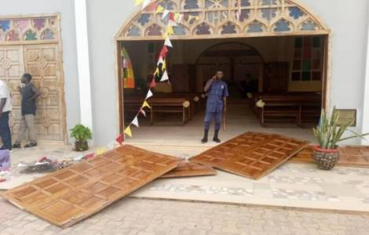
(15-5-23) Pope Francis lamented the new law: he said on May 13, “Today, the day when we commemorate the apparitions of the Virgin Mary to the shepherd children of Fatima – and today I am also very sad, because in the country where the Virgin appeared, a law is being passed to kill, a further addition to the long list of countries with euthanasia ...”
Tanzania - Acts of vandalism in the St. Carol Lwanga cathedral
(15-5-23) The bishops of Tanzania are scheduled to meet soon Pope Francis at the Vatican to discuss, among other things, alarming issues such as the desecration of several buildings of the Catholic Church in the country. To name a few, we recall the cathedral of the Virgin Mary, Queen of peace in the diocese of Geita desecrated on February 26, 2023. On May 3, St Patrick's parish in Zanzibar was also damaged by unknown persons and investigations are continuing. In the meantime, the acts of vandalism against church structures continue. In addition to these incidents, the desecration of St. Carol Lwanga Cathedral, diocese of Kahama, by a deranged man has been reported. He is reported to have escaped from the mental hospital, not far from the Cathedral. Security guards managed to catch him before he could do any more damage.
Holy Land - "Self-determination and a State for the Palestinian people". Heads of Churches in Jerusalem commemorate 75 years since the "Nakba"
(15-5-23) The Christian patriarchs of the Holy Land have renewed their call for the establishment of a Palestinian state.
In a message released for the 75th anniversary of the 1948 Arab-Israeli war, the Council of Patriarchs and Heads of Churches in Jerusalem asked for prayers “that God may grant wisdom to move towards a better future, so that the Palestinian people may be granted the right to self-determination, state building and prosperity, and allow all the peoples of this land to live in peace, dignity and prosperity.”
India - Karnataka chooses the Congress Party: a change for democracy and freedom
(15-5-23) "The election result in Karnataka could be a decisive moment in India's recent political history. The defeat of the Bharatiya Janata party (BJP), the ruling party until now in the state and also currently in the federal government, means that the doors of democracy are still wide open in the country. It is a significant result also looking ahead to the general elections scheduled for 2024", is the comment of Indian Jesuit Father Cedric Prakash, an intellectual and writer, on the May 10 elections in Karnataka, a vast federal state in south-western India with a population of about 70 million, which voted for the renewal of the state legislative assembly. According to official results, the nationalist BJP party of Indian Prime Minister Narendra Modi, which had the majority, came out heavily defeated in the vote. In this situation, the Congress Party would be able to form a state government without coalition partners.
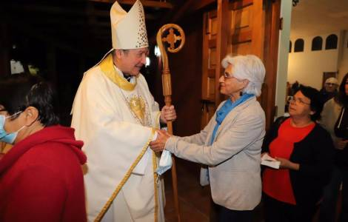
2023 is a crucial year for Indian politics. Elections are scheduled in five states of the Federation: in Karnataka, in Madhya Pradesh (where the BJP is in government), in Rajasthan and in Chattisgarh (led by the Congress Party), Telangana (now governed by a regional party).
"The elections in Karnataka - Father Prakash notes - are a watershed. The BJP invested a lot in the last days of the election campaign, with the presence of high-ranking politicians, like the Prime Minister himself and also with a door-to-door campaign. But… those who have governed so far have made it extremely difficult for the poor to make ends meet. In particular, they have no purchasing power: the cost of fuel is skyrocketing, they survive by the day, while unemployment is at an all-time high". The Jesuit pointed out that corruption among the ministers and legislators was a factor for the humiliating defeat.
Furthermore, Father Prakash notes, the inter-community and inter-religious polarization promoted by the BJP, has not had the desired effects: "Karnataka was once a haven of social harmony but, over the past few years, through a meticulously divisive campaign, denigrating religious minorities (Christians and Muslims), the BJP has polarized communities according to religious divisions, fomenting tensions. The BJP introduced a draconian anti-conversion law, criminalizing religious conversion and change of personal faith. Furthermore - recalls the religious writer - thousands of names of Muslim and Christian communities have disappeared from the electoral lists and have not been able to exercise their right to vote, despite protests sent to the Electoral Commission".
Non-governmental organizations and Christian communities in the state complain that "freedom of speech and expression have suffered a severe blow in Karnataka. Attempts have been made to block or silence those who take a stand for justice, truth and equality, and among them are lawyers, priests, religious, intellectuals".
Now the population, notes Father Prakash, has rejected all this. "The election result shows that in Karnataka there is a vibrant civil society, a network of citizens deeply concerned and committed to democracy and freedom, who wanted to promote change for the good and the future of India".
Chile - God's wisdom contrasts with 'politics' and many demographic 'programs': Bishop of Melipilla on Mother's Day
(15-5-23) "Celebrating Mother's Day must also mean a willingness on the part of those responsible for work, health, business and housing programs, so that women can fulfill their mission of motherhood welcomed by all. God's wisdom contrasts with the 'politics' and many demographic 'programs' of this world. The manger is a prophetic cry from God in favor of motherhood and life". This is a passage from the message that the Bishop Cristian Contreras Villaroel of Melipilla released on Sunday on the occasion of 'Mother's Day'.
India - Resignation of Bishop Allwyn D'Silva the auxiliary bishop of Bombay
(15-5-23) On May 13, 2023, the Holy Father Francis accepted the resignation from the office of auxiliary bishop of the archdiocese of Bombay, India, presented by Bishop Allwyn D’Silva, titular of Dura. He is 75 years old.

5 Chinese Christians held for ‘illegal gatherings’ get bail
(15-5-23) A court in Yunnan province in southwest China has granted bail to five ethnic minority Christians from the Nu and Lisu communities who were arrested and detained last August for allegedly “organizing and funding illegal gatherings.”
Among the arrested Christians is Wang Shunping, a pastor who served the local church after graduating from Yunnan Theological Seminary in 2014. He is a volunteer Bible and music teacher who taught guitar and piano to fellow Christians for free. About 80 percent of Lisu people identify themselves as Christians, according to ChinaAid.

Church gives aid to Mocha-hit areas in Myanmar
(15-5-23) The Church has dispatched aid materials to the hardest-hit regions of Myanmar after deadly Cyclone Mocha battered the Southeast Asian country on May 14.
Myanmar’s ruling junta put the death toll at three, while the shadow National Unity Government pegged the number of deaths, in one of the strongest-ever storms to hit the country, at 18.
Father Nereus Tun Min, director of Catholic charity Karuna Pyay, active in the hard-hit port city of Rakhine on the western coast and southern Chin state, said, “We have sent rice, oil, onion and tarpaulins to 40 families whose homes were damaged in Kyaukphyu township.” “We used our Lenten fund for the emergency response,” Father Tun Min told UCA News.
After the storm left a trail of destruction in Rakhine, the military-ruled government declared 17 townships as a natural disaster-affected area on May 15.
The priest said they are in touch with the national office of the Church's social arm, Karuna, to provide relief items in Sittwe, Kyauktaw and in Kyaukphyu township which are among the worst-affected areas. Many residences, including the clergy’s house in Sittwe, were badly damaged, the priest said.
Cyclone Mocha hit Myanmar and Bangladesh on May 14 packing winds of up to 248 kilometers per hour and copious amounts of rainfall. The storm was reported to be the strongest cyclone of the 16 that have occurred so far this year.

Catholic body calls on Indian Church leaders to ‘unite and fight’
(15-5-23) A group of priests and nuns urged the top Catholic Church leaders in India to bury the hatchet and work for unity to fight against rising persecution against minorities, especially Christians and Muslims.
“A divided Church cannot face a powerful adversary. Hence, the leaders in the Church shall take immediate and urgent steps to settle conflicts within it through a process of dialogue, and foster better cooperation and coordination among the three rites,” said the Forum of Religious for Justice and Peace (FORUM), a group of Catholic priests and nuns in an open letter on May 12.
The letter was addressed to Archbishop Andrews Thazhath, president of the Catholic Bishops’ Conference of India (CBCI), a national body of bishops from the Eastern rite Syro-Malabar, Syro-Malankara and Latin Churches that together make up India’s Catholic community. “The Catholic Church has to take leadership in networking with other churches and denominations in view of the huge challenges the minorities are facing in India under the pro-Hindu Bharatiya Janata Party (BJP) regime,” the Forum said.
The letter comes against the background of a lukewarm response from the top leadership of the Church over the persecution of Christians during the sectarian violence in the northeastern state of Manipur.
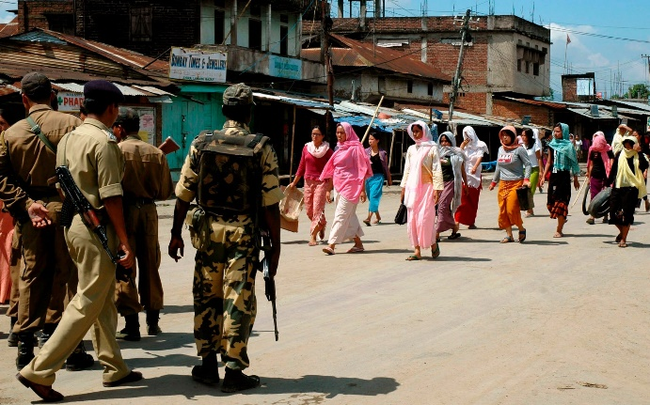
The violence that began on May 3 has reportedly killed 60 innocent people, injured 230, and displaced over 35,000 people. Some 1,700 houses were destroyed and 100 Churches burnt down in one of the worst targeted attacks on Christians in the state. The actual loss of lives and property is believed to be far more than what has been reported.
“We are upset about the lukewarm response of the official Church to the increasing violence against Christians,” the letter said and expressed disagreement with Catholic leaders including Cardinal George Alencherry, major archbishop of the Syro-Malabar Catholic Church, who had spoken in support of Prime Minister Narendra Modi. “Christians are safe under the Modi regime,” Cardinal Alencherry said in a recent interview with The Indian Express, an English newspaper.
The letter also reminded Catholic Church leaders about a recent protest against rising attacks against the community by Christians of all denominations in the national capital New Delhi. “Christians in India, especially the Catholics, are highly confused during this crisis period because of the ambivalent, confusing and even contradicting statements coming out of the Church leaders,” the letter noted.
Crux
The Forum further pointed out that while the CBCI president [Archbishop Thazhath] was satisfied with making an appeal for praying for peace in Manipur, Cardinal Anthony Poola, the archbishop of Hyderabad, and Archbishop Peter Machado of Bangalore had shown courage and compassion to condemn the violence in Manipur.
The letter said the whole country is being led to a disastrous situation of fascism, destruction of democratic institutions, rampant violation of human rights, suppression of any kind of dissent, skyrocketing economic inequalities, and the gifting of public resources and services to some favoured billionaire corporate leaders.
“At this crucial juncture, the Church cannot be silent or cannot appear to be supportive of the anti-people government; it has to play a prophetic role. It is our suggestion that the CBCI shall take initiative to organize an ‘All-India Seminar: The Church in India Today’ to evolve policies and strategies to face the current challenges,” it said while suggesting the participation of bishops, priests, religious women, and men, lay women and men, experts in politics, economics, law, media, etc.
The Church leaders were asked to rise to the occasion, “leaving behind their petty and vested interests, for the sake of the people of India and prove themselves to be good shepherds who do not run away when the wolf comes to attack the sheep."

10 people arrested on conversion charges in India
(15-5-23) Police arrested 10 people under the stringent anti-conversion law after a raid on a Christian prayer gathering in a central Indian state.
Some 70 Christians had gathered at a private residence in Kotwali in the Shahdol district of Madhya Pradesh state run by pro-Hindu Bharatiya Janata party (BJP) on May 13 when a police team arrived and stopped their prayer meeting alleging "religious conversion activity."
“Our people were arrested after branding the routine prayer meeting as a conversion activity,” a pastor speaking to UCA News on condition of anonymity said on May 15. Police also seized copies of the Bible and other documents from the residence. The 10 people who were arrested were produced before a court and remanded in judicial custody.
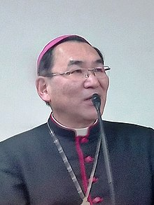
16-5-23

Tokyo archbishop elected new president of Caritas
(16-5-23) Archbishop Tarcisius Isao Kikuchi, SVD, of Tokyo was elected the new president of Caritas Internationalis, the Church’s confederation of humanitarian and development agencies, for a four-year term at its general assembly.
New US report alleges religious freedom violations in China, Iran, India
(16-5-23) On May 15, the US State Department released its 2022 Report on International Religious Freedom.
“Governments in many parts of the world continue to target religious minorities using a host of methods, including torture, beatings, unlawful surveillance, and so-called re-education camps,” said Secretary of State Antony Blinken. (cf Attached file)
French bishops to issue ID cards for priests in good standing
(16-5-23) French Catholic clerics will soon carry identification cards to certify that they are in good standing.
The French bishops’ conference plans a national database of priests and deacons, “to prevent imposters from continuing to act to the detriment of the faithful and the sacraments.” The initiative grew out of conversations about protecting the faithful from priests credibly charged with abuse, and expanded to include protection against any others seeking to impersonate priests.
Sharp rise in executions worldwide in 2022
(16-5-23) At least 883 people were put to death by legal execution in 2022, according to figures released by Amnesty International. That number represents a increase of more than 50% over the previous year.
However, the Amnesty International figures do not include executions in China—where the government condemns thousands of people to death every year—and in other countries that withhold information about capital punishment.
In the Amnesty International report, three countries—Iran, Saudi Arabia, and Egypt—account for more than 90% of last year’s executions.
African bishops appeal for debt cancellation ahead of G7 summit
(16-5-23) As leaders of the G7 nations prepare to meet in Hiroshima, bishops from 23 African nations called for “effective and reliable processes to alleviate unpayable debts.”
South Carolina parish vandalized
(16-5-23) The vandalism at Immaculate Conception Church in Goose Creek, South Carolina, is one of over 250 acts of vandalism, arson, and other destruction at parishes and other Catholic sites in the United States since May 2020.
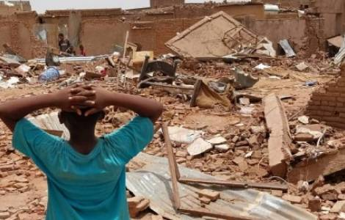
Sudan - A month of war: the population is at the end of their tether and the country in chaos
(16-5-23) Fighting and looting continue to hinder humanitarian groups from working to help the Sudanese population who are exhausted after a month of armed conflict. The situation in the country does not seem to stop despite the various truce agreements agreed between the parties and quickly violated. Agencies have focused on the evacuation of their international staff and the relocation of some national staff as well. Most Sudanese remain in the country, along with many missionary priests and nuns. Some hope things will return to normal, while others cannot leave because they do not have the money for transport or the physical ability to move.
In the current context, there seems to be no hope that an imminent political solution can be reached between the two coup generals, the federal army chief Abdel Fattah al-Burhan and his former deputy Mohamed Hamdan Dagalo, known as Hemeti, who heads the paramilitaries of the Rapid Support Forces (RSF), and the population is at risk of starvation.
DR Congo - After the conflicts in the east of the country, instability in the west which is approaching the capital
(16-5-23) The latent conflict in the west of the Democratic Republic of Congo is worsening, reaching areas not far from the capital, Kinshasa.
Between May 11 and 13, the "Mobondo" militia of the Yaka community was accused of having attacked some villages in the province of Kwango, starting with Nguma, 75 kilometers from Kinshasa, and then spreading to that of Batshongo (located on the border between Kwango and Kinshasa provinces) and other villages located along National Route 1 which connects these areas with Kinshasa. The army has managed to regain control of this important artery, restoring connections with the capital. At least eleven people died in the two-day fighting, including several beheaded soldiers. The number is increasing, since a few days later the bodies of two civilians murdered at the scene of the clashes were found.
The Kwango provincial government is trying to regain control of the situation by tightening security measures in the region. Army and police patrols have been strengthened to prevent the escalation of violence.
Colombia - Educating young people for peace, a sign of hope in the midst of the Colombian conflict
(16-5-23) Education is essential to prevent children and adolescents from repeating the violence that plagues the region. This was stated by Juan Casas, director of the Jesuit Refugee Service Colombia (JRS).
The international Catholic organization is closely following the alarming situation of children and young people in the border areas between Colombia, Ecuador and Venezuela, areas that do not have adequate infrastructure or services and suffer from the persistent conflict in Colombia that particularly affects children and young people.
"The presence of the army frightens the civilian population because moments of confrontation between the guerrillas and the military generate violence and the latter, in turn, cause displacement", Casas continues after his recent visit to Serranía de San Lucas, a highly inaccessible area, where armed conflict is a constant threat. “Children play at being soldiers or guerrillas. With a broomstick they pretend to have a rifle in their hands. Or they hood up with a sweater. They reproduce what they see. But sadly, those games can become reality”.
For JRS, it is urgent to build spaces for peaceful coexistence. The organization has been involved for years, together with teachers and families involved in the education of children and young people at risk.

Young Asians to spread papal document on human fraternity 16
(16-5-23) School students from several Asian nations came together in Singapore to launch an international fraternity to propagate the ideals of the human fraternity document signed by Pope Francis and the Grand Imam of Al-Azhar in 2019.
The Asian Young Leaders for Human Fraternity (AYLHF) was launched during the 70th founding anniversary of the Catholic-run Assumption English School (AES), Singapore archdiocese-run news website Catholic News reported early May.
The fort meeting of the ecumenical initiative brought together 84 students and 12 teachers from Singapore, Indonesia, Japan, and Thailand. It aims to promote peace among people of various faiths, religions, and cultures in Asia.
It was inspired by the Document on Human Fraternity for World Peace and Living Together signed by Pope Francis and the Grand Imam of Al-Azhar, Ahmed el-Tayeb in Feb 2019 at Abu Dhabi. This celebrated document is considered a Christian-Muslim manifesto for peace among all people in the world.
Concern in Indonesia over illegal arms supply to Papuan rebels
(16-5-23) An Indonesian Catholic lawmaker has called on the army chief to explain the alleged sales of arms and ammunition to rebel groups by military forces in the restive Christian-majority Papua region.
"This matter is very serious and we in parliament certainly want to hear a full explanation from the Commander of the Indonesian Armed Forces," said on May 16 Christina Aryani, a lawmaker on the parliamentary commission related to defence, foreign affairs, communications, informatics, and intelligence.

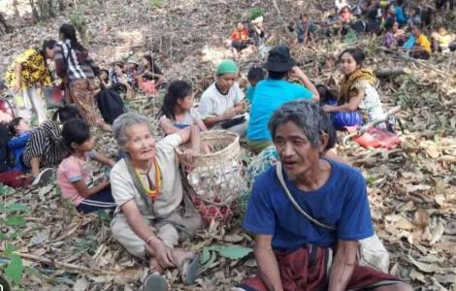
Cyclone Mocha death toll hits 81 in Myanmar, Church’s aid in Bangladesh
(16-5-23) The death toll in cyclone-hit Myanmar rose to at least 81 on Tuesday 16 May, according to local leaders, officials and state media, as villagers tried to piece together ruined homes and waited for aid and support.
Mocha made landfall on Sunday 14 May with winds of up to 195 kilometers (120 miles) per hour, downing power pylons and smashing wooden fishing boats to splinters.
At least 46 people died in the Rakhine state villages of Bu Ma and nearby Khaung Doke Kar, inhabited by the persecuted Rohingya Muslim minority, local leaders told AFP reporters at the scene.
Meanwhile, Church groups, like Caritas Bangladesh, and international agencies have rushed relief materials to cyclone-hit Bangladesh which is struggling to limp back to normalcy. Bangladesh’s disaster management and relief ministry said 13,000 houses have been damaged, mostly in the southeastern Cox’s Bazar district, though over 4,00,000 people had earlier been evacuated to shelter camps.
Church in strife-torn Indian state appeals for peace, help
(16-5-23) The Catholic Church in the violence-hit Manipur state in northeastern India has appealed for help as more than 45,000 people continue to live in cramped relief camps.
Archbishop Dominic Lumon of Imphal Archdiocese said those in camps are in need of food and clothing among other basic things and sought people's support for them. His May 14 message said he was “pained, saddened and most of all concerned" by the situation of the people's suffering.
The ethnic violence that began on May 3 killed some 60 people amid looting and burning of houses and the destruction of places of worship that has left thousands of people displaced, languishing in military barracks and relief camps.
“There is fear, uncertainty and a general sense of hopelessness and desperation,” Archbishop Lumon said. He also stressed the need for helping the people who lost their houses and income sources to rebuild their lives as “many have no place to go.”
17-5-23

Pope, at general audience, pays tribute to St. Francis Xavier
(17-5-23) Continuing his series of Wednesday catecheses on the theme of “the passion for evangelization: the apostolic zeal of the believer,” Pope Francis devoted his May 17 general audience to St. Francis Xavier (1506-1552). Here’s the summary of what he said:
In our continuing catechesis on apostolic zeal, we now turn to Saint Francis Xavier, the patron of the Catholic missions. Born in Spain, Francis studied in Paris, where he met Saint Ignatius of Loyola and, together with a few companions, formed the Society of Jesus, placing themselves at the service of the Pope for the most urgent needs of the Church of their time. The sixteenth century, the age of discovery, called for a great missionary outreach. Francis set out for the East Indies, where, starting in Goa, India, he carried out an intense activity of preaching, baptizing, catechizing and caring for the sick. From India, he passed to the Maluku islands in today’s Indonesia, and from there to Japan. Unable to fulfil his dream of entering China, Francis died, at only forty-six years of age, on the nearby island of Shangchuan. His heroic zeal for evangelization was the fruit of a life of deep prayer and loving union with the person of Jesus Christ. May the example of Saint Francis Xavier inspire our own efforts to advance the Church’s mission, as joyful witnesses to the risen Lord and his saving word.
German Catholic Church could face financial collapse
(17-5-23) German Catholic dioceses will be forced to sell off thousands of parish churches, rectories, and charitable agencies in future years, because of the steep decline in the number of practising Catholics, a new report predicts.
The number of German Catholics leaving the Church—and thus avoiding the obligation to pay the “church tax” that sustains the dioceses—reached an all-time high of almost 360,000 last year. Although about 21 million Catholics remain in Germany, less than 5% attend Mass, and as the exodus continues, the revenues from the “church tax” are likely to plummet.

Pope Francis marks 650th anniversary of Julian of Norwich’s visions
(17-5-23) Pope Francis sent a message to participants at events in the Catholic and Anglican cathedrals in Norwich, England, to mark the 650th anniversary of the revelations to Julian of Norwich.
“On May 13, 1373, Julian was healed of a serious illness after experiencing a series of visions of Christ’s suffering and of the Blessed Virgin, about which she wrote two accounts; the second, longer version was composed 20 or 30 years after the first,” Encyclopaedia Britannica notes in its article on the English mystic. Julian’s accounts of her visions are known as the Revelations of Divine Love, or the Showings (Shewings).
“The profound significance of this English mystic for the Christian tradition speaks to us from across the centuries and is increasingly being acknowledged and celebrated,” Pope Francis wrote in his message, dated May 8 and reported by Vatican News on May 15. “Indeed, her maternal influence, humble anonymity, and profound theological insights stand as timely reminders that faith in God’s loving providence and holiness of life expressed in generous service to our brothers and sisters in need, are timeless truths underpinning not only the life of Christian discipleship but the very fabric of a just and fraternal society.”
Pope interrupts audience to take phone call
(17-5-23) Pope Francis interrupted his regular weekly public audience on May 17 to take a phone call.
As the Pope was greeting groups of pilgrims in attendance at the Wednesday audience, an aide brought him a cell phone. The proceedings then stopped for about a full minute, as the Pontiff spoke on the phone while the crowd in St. Peter’s Square waited quietly.
The Vatican did not answer queries about the nature of the call. Pope Francis has interrupted public audiences to take phone calls a few times in the past.
WCC general secretary visits Moscow and Patriarch Kirill
(17-5-23) 350 Protestant and Orthodox communities are members of the World Council of Churches, which is headquartered in Geneva, Switzerland. Pope Francis made an ecumenical pilgrimage to Geneva in 2018 for the World Council of Churches’ 70th anniversary.
Sudan - Massacre in Darfur and camps ready to welcome refugees in South Sudan
(17-5-23) While the fighting continues to intensify in Khartoum, the most serious situation in terms of human casualties is in the province of Darfur. In the past week, clashes have claimed more than 350 lives in the capital Geneina alone. The intensity of the aerial bombardments has forced some militant units to abandon their positions and flee the city.
Against this chaotic context, the South Sudanese government has pledged to welcome the ever-growing number of fleeing refugees. At a press conference in Juba, Humanitarian Affairs Minister Albino Akol Atak announced that the government of the northern state of Bahr el Ghazal had allocated land to establish a new refugee camp in the state. The new refugee camp is located in Wetwil, in the town of Aweil, and is ready to accommodate the 7,500 asylum seekers currently in Kiir-Adem.
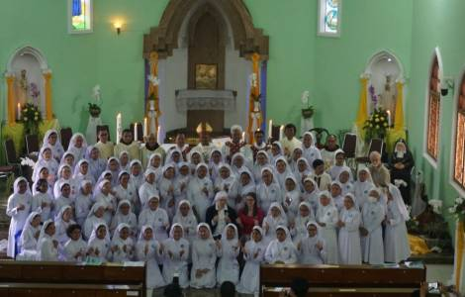
According to government officials, since the conflict broke out in Sudan last April, South Sudan has welcomed about 70,000 returnees and asylum seekers, including Sudanese, Eritreans, Ugandans and Kenyans, among others. Indonesia - The Franciscan Sisters of Sukabumi were born from a Dutch religious congregation’s mission
(17-5-23) The missionary history of the Franciscan Sisters in the city of Bergen op Zoom (Boz), in the Netherlands, fully expresses the authentic spirit and apostolic dedication of many people and congregations who, in their missionary work, they have detached themselves from any colonialist approach and have fully immersed themselves in the local context. To the point of becoming an integral part of it, eventually dissolving and giving rise to a local religious congregation. This whole historical process was remembered in Indonesia - a land where the Portuguese settlers arrived first and then the Dutch- in a celebration organized these days by the Congregation of the Franciscan Sisters of Sukabumi (SFS), a city in West Java, who celebrated the 90th anniversary of its presence in Indonesia, recalling its foundation in 1933. Although, at that time, the institute did not have that name and was only made up of European missionaries.
A Dutch Franciscan nun, Sister Rosa de Bie, was the first to go on a mission there and opened the door of the first convent 90 years ago. The religious congregation of Sukabumi is, in fact, the "Indonesian version" of the Dutch religious institute of the Franciscan Sisters of Bergen op Zoom. It assumed and adopted the Franciscan spirituality, recognizing itself as "a branch of that plant" and recognizing it as its inspiration and root.
Colombia - Families "promoters of human life, builders of society, custodians of the common home and active subjects of evangelization"
(17-5-23) "The purpose is to highlight that the family, living its vocation to be a community of life and love, is the protagonist of human life in all its dimensions. We need families to increasingly assume their irreplaceable vocation of being promoters of human life, builders of society, protectors of the common home and active subjects of evangelization". This is stated by the Department of Marriage and Family of the Episcopal Conference of Colombia, speaking of the "Family Week 2023" that Colombians are experiencing from May 14 to 21.
During these days, also inspired by the International Day of the Family, convened each year by the United Nations for May 15, the Bishops invite reflection and prayer for all the families of the country, recognizing their role as main formators of Colombians willing to contribute to the construction of a better country and for Christian families, protagonists of the missionary effort.

Catholic nuns to foster dialogue between Japan, S. Korea
(17-5-23) Catholic nuns from South Korea and Japan joined a regional meeting in Seoul where they decided to promote and work towards a “culture of listening, dialogue, discernment, care, and peace” in both nations.
The nuns made the decision during the Korea-Japan General Assembly of the International Union of Superiors General held at the National Reconciliation Centre in Paju near Seoul from May 9 to 14.
The heads of 18 female religious orders in Korea and 10 religious orders in Japan attended the conference with the theme “Embracing Vulnerability on the Synodal Journey.”
During the concluding Mass, Bishop Peter Lee Ki-heon of Uijeongbu Diocese said that he believes the decision of the nuns can help resolve various regional issues between both nations.

Indian pastor, seven others arrested on conversion charges
(17-5-23) Eight people including a pastor and his wife were arrested by police for violating the anti-conversion law in two separate incidents reported from a northern Indian state.
Pastor Ibrahim Thomas, his wife Reewa, and Babita Thakur were arrested on May 14 in Uttar Pradesh’s Ghaziabad city for allegedly trying to convert women inside a beauty parlour.
The complaint was filed by Sunita Arora, a local leader of the pro-Hindu Bharatiya Janata Party, alleging she was called to a beauty parlour near her home in Khoda colony and asked to convert to Christianity, according to media reports.
The beauty parlour is run by Thakur and Thomas and his wife were preaching to a group of women assembled there, Arora claimed while adding that she left immediately and called her supporters before deciding to file a complaint with the police.

Indonesian Catholic minister detained for graft
(17-5-23) Indonesian authorities have detained the only Catholic minister in the current cabinet after he was named a suspect in a multi-million-dollar corruption case involving the construction of communication infrastructure in remote areas, including in Christian-majority provinces.
Johnny Gerard Plate, the minister of communication and informatics was detained by the Attorney General’s Office on May 17.

Bangladesh urged to act on US report
(17-5-23) Interfaith groups and minority outfits have urged the Bangladesh government to act on the annual United States International Religious Freedom (USIRF) report which said Christians, Hindus, and Buddhists are often targeted in the South Asian nation.
“The perpetrators of communal violence largely enjoy impunity," the report, released on May 16 in Washington, said about Bangladesh.
“What the report says is true,” said Rana Dasgupta, general secretary of the Bangladesh Hindu Buddhist Christian Unity Council. “The government should act to free religious minorities of the fear and apprehension with which they live in Bangladesh,” Dasgupta observed. Dasgupta noted that the population of minorities has decreased by 10 percent over the last five decades since Bangladesh’s independence in 1971.

Police guard kills 2 girl students in Pakistan
(17-5-23) Two school girls, including a 9-year-old, were killed and five others hurt when a police constable opened fire at a missionary Catholic school on May 16 in Pakistan's northwest province.
The school, managed by the Sisters of the Presentation of the Blessed Virgin in Sangota in Pakistan's restive Swat Valley in the northwestern Khyber Pakhtunkhwa province, was targeted at around 2 p.m. when students were getting ready to leave the school in a van.
“I was panicked after seeing blood on the foot of my daughter. The vehicle was parked inside the school when the firing started,” said a parent. Angry parents protested and blocked the road outside the school soon after the shooting.
Alam Khan, a police constable posted to Sangota Public School, built in 1962, to provide security in February, has been arrested as part of the ongoing probe.
“The initial statement of the District Police Officer to the school management was that the constable 'was mentally ill' and suspended 'twice for violent behavior,'" Archbishop Joseph Arshad of Islamabad-Rawalpindi told UCA News. He has instructed all the 448 Church-run educational institutions in the Muslim-majority nation to hold a day of prayer in solidarity with the missionary school.
18-5-23

Indonesian students' Sharia support worries Church
(18-5-23) A new survey that said more than 56 percent of high school students across five cities in Indonesia stood for implementing the Islamic Sharia law has caused concern among Church leaders and educators.
"Support for the perception that Pancasila (secular ideology) is not a permanent ideology, meaning that it can be replaced, is also very large, namely 83.3 percent of respondents," according to the survey released on May 17 by the advocacy group Setara Institute for Democracy and Peace in association with the International NGO Forum on Indonesian Development (INFID). Father Antonius Benny Susetyo, a member of a presidential unit for promoting communal tolerance, said the findings were worrying because it happened in schools, where Pancasila was one of the concerns.
"All parties, including the Ministry of Education and Culture, must find out why intolerant views are growing in schools," the priest said.

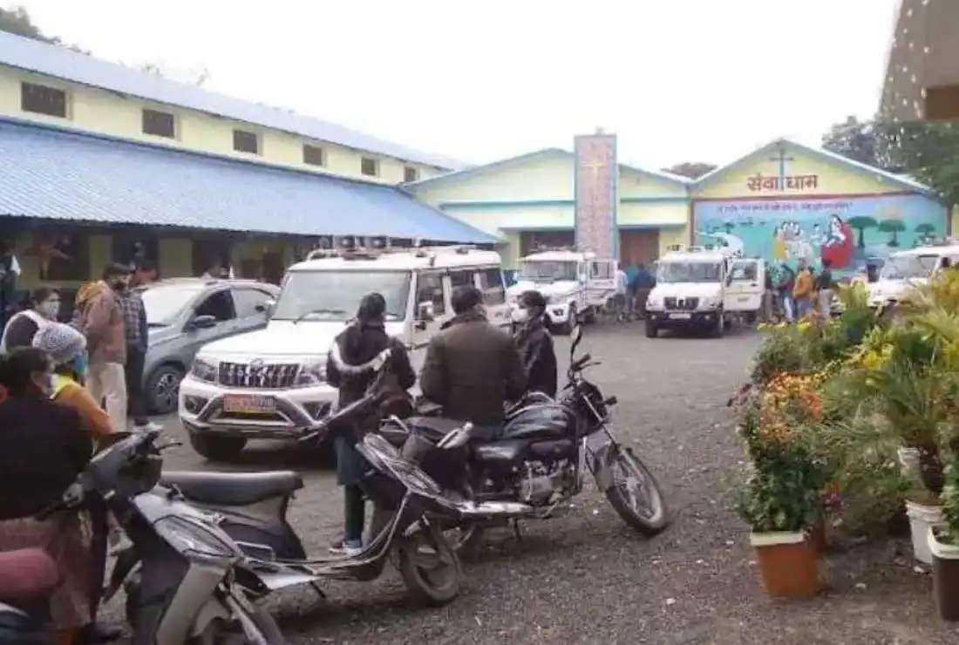
Indian authorities continue to target Catholic orphanage
(18-5-23) Authorities in a central Indian state are continuing to target a centure old Catholic orphanage despite court orders preventing them from attempting to remove children living there, its administrators say.
The Child Welfare Committee (CWC) in Sagar district of Madhya Pradesh on May 15 issued an order to shift 26 boys and girls from the St. Francis Sevadham Orphanage in Sagar diocese to a government-run shelter within two days. However, the order was withdrawn a day later after diocesan officials filed a contempt of court petition with the state's top court. “It has become very difficult for us to run the orphanage as government agencies continue to harass us,” Father Sinto Varghese, its director told UCA News.
The Madhya Pradesh High Court in December 2021 directed authorities not to remove the children and also sought a report from the CWC explaining the need to do so. “This is the sorry state of affairs,” Father Varghese said, adding that this was the third time since May 8 that they had to go to court because of the harassment. "When we file a contempt petition, the CWC reverses its order but the torture continues,” the priest added. The diocesan officials also handed a memorandum to Madhya Pradesh Chief Minister Shivraj Singh Chouhan on May 12 explaining the situation.
“What is our fault? Is it serving the poor? I don’t know how we will be able to work in such a hostile environment with government agencies, who are meant to protect us, repeatedly harassing us,” Father Varghese said.

Malaysian church drops legal bid against ‘Allah’ use ban
(18-5-23) An Evangelical church in Malaysia has decided to discontinue its 16-year-long legal battle against a 1986 government ban on the use of the word ‘Allah’ in Christian publications for its Bahasa Malaysia-speaking members.
Sidang Injil Borneo (Evangelical Church of Borneo) based in Sabah state announced in a notice its decision to discontinue the court case against the Home Ministry, Malay Mail reported on May 17.
The court case was filed after the Home Ministry seized and withheld the church’s Christian education materials that carried the word “Allah” in 2007. Allah is the word for god in the local language, Bahasa Malaysia, but Muslims maintain non-Muslims should not use it because it is exclusively reserved for the God of Muslims. The church filed the case after the Home Ministry refused to return three boxes of books, only meant for the church’s children and not for sale, the report said.
The notice of discontinuance was confirmed by the church’s president Reverend Jerry Dusing.
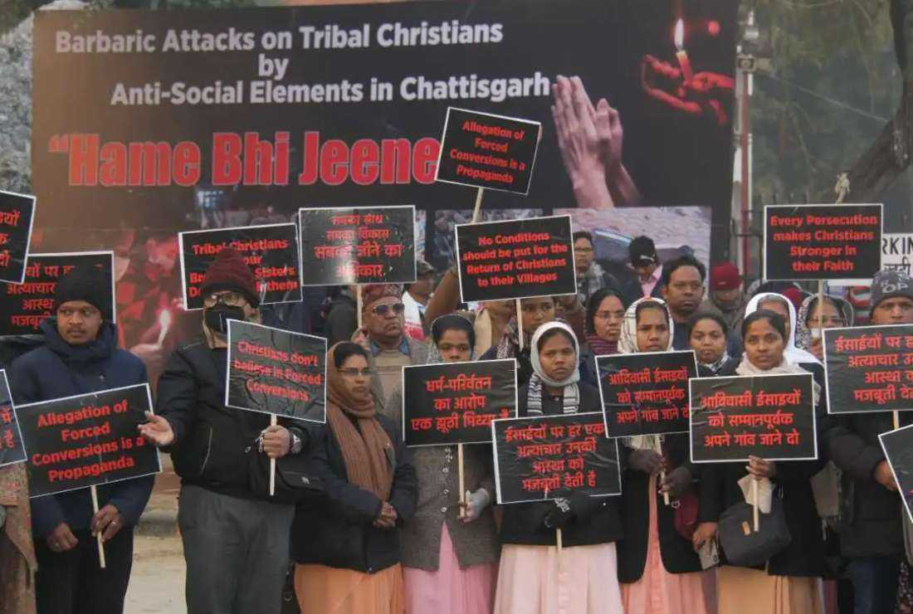
With the Evangelicals dropping the case, there are no outstanding court cases involving Christians seeking the right to use the word “Allah.”

Indian Catholic leader underscores rise in Christian persecution
(18-5-23) A Catholic lay leader in India's national capital, Delhi has pointed to a marked rise in the persecution of Christians as the federal government rejected a US State Department report citing deteriorating religious freedom in the country.
India’s federal Ministry of External Affairs (MEA) on May 17 called the US State Department's 2022 Report on International Religious Freedom (USIRF) “flawed, motivated and biased.”
However, A.C. Michael, president of the Federation of Catholic Associations of Archdiocese of Delhi told UCA News, “I personally do not believe in another country interfering in our internal matters, but one cannot deny that well-orchestrated and pre-planned incidents of violence against Christians have increased drastically from 147 incidents in 2014 to 599 in 2022.” Michael, a former member of the Delhi Minorities Commission further said that “as a matter of fact in 120 days this year, 233 incidents of violence have taken place against the community across 21 states in India.”
The US State Department report released on May 16 expressed concern about religious freedom worldwide, including in India where it highlighted targeted attacks on minorities and hate speeches, especially against Christians, Muslims and Dalits.
The timing of the report is significant as it comes just a month before Indian Prime Minister Narendra Modi’s upcoming visit to the US and the latest sectarian violence reported in the northeastern state of Manipur that has claimed 71 lives so far and displaced several thousands of people, mostly tribal Christians.
Michael told UCA News that besides the violent incidents, Christians were being targeted across various states through laws that ban religious conversions. “The so-called ‘Freedom of Religion Acts’ implicate members of the community including their priests with false allegations of conversion,” he said. Michael stressed that even though the Indian Supreme Court on Sept. 1, 2022, asked for a list of forceful conversions, the federal and state governments had failed to provide one “as there are no forceful conversions taking place in our country.”

India’s top court seeks report on riots in Manipur
(18-5-23) India’s top court has sought a report on the sectarian violence that claimed 71 lives in the northeastern hilly state of Manipur.
The Supreme Court on May 17 asked the state, ruled by the pro-Hindu Bharatiya Janata Party, to furnish a fresh status report while hearing a petition filed by the Manipur Tribal Forum for urgent intervention of the top court to contain the violence.
The violence erupted on May 3 after the state high court suggested that the government give special tribal status to the majority Meitei Hindu community. Indigenous Kuki people, most of them Christians, protested it, igniting riots. The violence injured 231 people and damaged 1,700 houses and 121 churches, besides displacing over 45,000 people, local reports said.

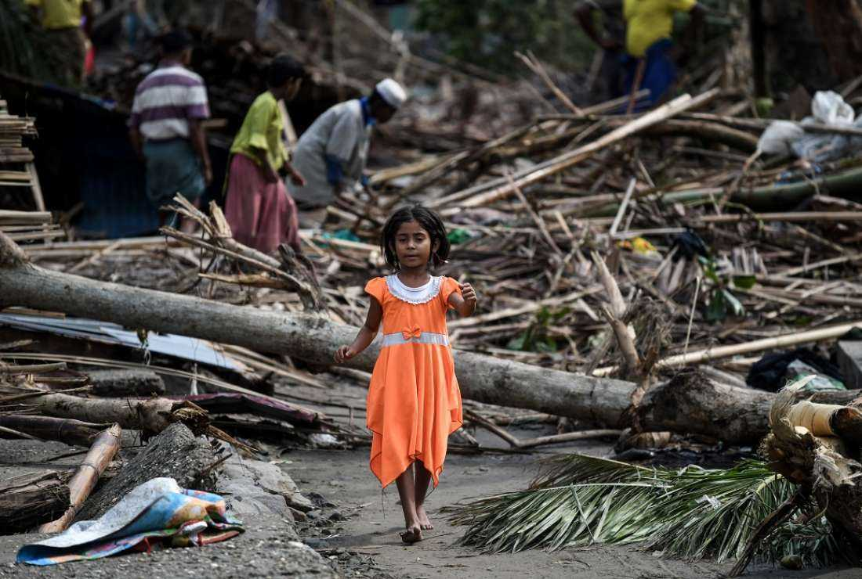
Cyclone hits Myanmar churches, shelter camps hard
(18-5-23) Churches and shelter camps for internally displaced persons (IDPs) have been destroyed in large numbers in a predominantly Christian region in civil war-affected Myanmar after deadly cyclone Mocha struck on May 14, aid and civil groups say.
Father Nereus Tun Min, director of Catholic Karuna Pyay that covers worst-hit Rakhine state and Paletwa township in northwestern Chin state, said the Sacred Heart Catholic Church in the port city of Sittwe in Rakhine state was badly damaged, along with churches in other townships.
The priest added that the Catholic Church has mobilized a team of workers from Karuna (Caritas) who will reach Sittwe this week.
19-5-23
Pope sending envoys to Moscow, Kyiv?
(19-5-23) Pope Francis is sending personal envoys to Moscow and Kyiv, in a bid to arrange a truce between the warring countries, according to a Roman report.
Il Sismografo, an influential blog that covers Vatican affairs, reports that both Russian President Vladimir Putin and Ukrainian President Volodymyr Zelenskyy have agreed to meet the papal representatives.
Vatican officials have not commented on the report. But Pope Francis had said, in an in-flight conversation with reporters on April 30 as he returned from a visit to Hungary, that there was a “mission underway” to secure a peace agreement.
According to Il Sismografo, Cardinal Matteo Zuppi of Bologna would be the papal representative to visit Kyiv, while Archbishop Claudio Gugerotti, the prefect of the Dicastery for Eastern Churches, would travel to Moscow. Archbishop Gugerotti, who speaks Russian, has in the past served as papal nuncio to Ukraine and to Belarus.
Car rushes Vatican gate, is fired on by gendarmes
(19-5-23) The car’s driver, described as a man in a “serious state of psychophysical alteration,” was arrested in the San Damaso Courtyard of the Apostolic Palace.
After questioning, the driver was taken to the psychiatric ward of a local hospital for “mandatory medical treatment.”
German dioceses push ahead with lay leadership, ignoring Vatican
(19-5-23) German dioceses are moving forward with plans to establish governing boards that include lay leadership, despite Vatican warnings against such plans.
“Our ‘Rottenburg Model’ is not up for discussion,” said Bishop Gebhard Fürst of Rottenburg-Stuttgart, referring to a proposal for lay representation in all diocesan governing bodies. He said the plans were “a clear consequence of the Second Vatican Council.”
In Osnabrück and Paderborn, Church leaders are also setting up governing boards that include lay Catholics. In Osnabrück, whose Bishop Franz-Josef Bode resigned in March, a panel of nine priests and nine lay people is assessing the future of the diocese.
The Vatican has cautioned that such panels violate the principle that the bishop, as successor to the apostles, has the sole ultimate responsibility for setting diocesan policies.
Europe cannot accept war in Ukraine, Cardinal Parolin says
(19-5-23) In an address to a summit meeting of the Council of Europe, Cardinal Pietro Parolin said that Europe could not allow the continuation of warfare in Ukraine.
“We cannot accept passively that the war of aggression in that tormented country continues,” said the Vatican Secretary of State. He asked: “where are the creative efforts for peace?”
Papal message to CELAM highlights synodality, service
19-5-23) Cardinal Pietro Parolin, the Holy See’s Secretary of State, sent a message in the Pope’s name to CELAM (the Episcopal Conference of Latin America) as it held its 39th general assembly.
The Pope prayed that the Church there be “always ready to serve, especially the poor and the marginalized, discerning the inspirations of the Holy Spirit, in synodality with all the holy people of God.”
Meanwhile, Archbishop Jaime Spengler of Porto Allegre, Brazil, who was recently chosen to head the Brazilian bishops’ conference, was elected president of CELAM.

Archbishop Gänswein meets Pope: to discuss new assignment?
(19-5-23) Archbishop Georg Gänswein, who was private secretary to the late Pope Benedict XVI, met Pope Francis in a private audience on May 19.
Although the Vatican did not disclose the topics discussed at the meeting, it is likely that the Pope spoke with the German archbishop about a new assignment. The two had met in January, after the death of Pope Benedict .
On paper, Archbishop Gänswein still has a Vatican assignment, as Prefect of the Pontifical Household.
Ukrainian priests, seized by Russian troops in November, still detained
(19-5-23) Two Ukrainian Catholic priests who were taken into custody by Russian troops in southeastern Ukraine in November 2022 remain detained, the Forum 18 news service reports.
Fathers Ivan Levytsky and Bohdan Heleta were seized by Russian troops who took control of the region. Officials of the Donetsk exarchy (diocese) have no knowledge of their whereabouts, and are not sure whether they are still alive.
Nicaragua closes Catholic university
(19-5-23) The government of Nicaragua has closed down Immaculate Conception University, in the latest of a series of actions against the Catholic Church.
The government announced that the university, which is run by the Archdiocese of Managua, had closed voluntarily. Church officials denied that report. The university had offered training for seminarians.
Pontifical academy establishes task force on alleged Marian apparitions
(19-5-23) The Pontifical International Marian Academy has established an international observatory, or task force, on Marian apparitions and mystical phenomena in the world.
“The objective is to analyze and interpret ... apparitions, tears, internal locutions, stigmata and other mystical phenomena that are still ongoing or have already concluded, on the authenticity of which the ecclesiastical authority has not yet definitively pronounced,” the Vatican newspaper reported.
Father Stefano Cecchin, OFM, the pontifical academy’s president, said that the observatory will operate “in harmony with the ecclesiastical magisterium, the competent authorities, and the norms in force of the Holy See.” He added that “alleged [Marian] messages often generate confusion, spread anxious doomsday scenarios, or even accusations against the Pope and the Church.”
Australian state drops plan to take over Catholic cemeteries
(19-5-23) The government of New South Wales has backed away from a plan to take control of the state’s Catholic cemeteries.
Archbishop Anthony Fisher of Sydney had fought the plan, saying that the government’s proposal to merge cemetery management into a single government agency showed a “blatant disregard for people of faith.”
Vatican withdraws postage stamp after protests
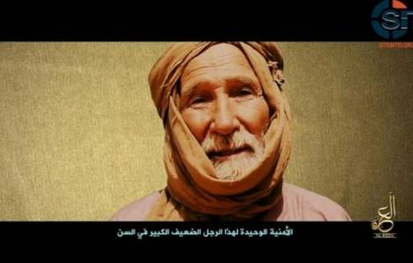
(19-5-23) The Vatican has withdrawn from circulation a postage stamp that was released to publicize World Youth Day, but drew criticism because it used an image associated with colonialism.
The stamp—promoting the World Youth Day celebrations in Lisbon—showed an image of Pope Francis leading young people to the Monument of Discoveries, a prominent landmark in the city. That monument is now controversial for two reasons: It was constructed during the authoritarian regime of Antonio Salazar, and it was built to honor the 500th anniversary of the death of Henry the Navigator, a key figure in Portugal’s colonial expansion.
Mali - Arthur Kenneth Elliott freed after seven years of imprisonment
(19-5-23) The news of the release of Arthur Kenneth Elliott, the Australian doctor kidnapped in Burkina Faso seven years ago, arrived a few hours ago. It was exactly on January 15, 2016 when Dr. Elliot, now 88, was abducted with his wife Jocelyn. The couple were abducted in Djibo, on Burkina Faso's border with Mali, where they had been running a 120-bed clinic for more than 40 years. Jocelyn Elliott was released after three weeks. "Elliot is safe and sound and back in Perth with his wife and children", Australian Foreign Minister Penny Wong said.
"We want to thank God and everyone who continued to pray for us," Elliott's family said in a statement released by the ministry.
Indonesia - Traveling and promoting the spirituality of dialogue and "dialogue of life": the path of the Focolare Movement
(19-5-23) With the visit to the Catholic parish of St. Odilia in Tangerang, in the archdiocese of Jakarta, the visit to Indonesia of Margaret Karram and Jesús Morán, President and Co-President of the Focolare Movement, on their first official trip to Asia and Oceania. In recent weeks, both stopped in Korea, then visited Japan, the Fiji Islands, Australia and now Indonesia. The meeting was attended by Archbishop Ignatius Suharyo of Jakarta, representatives of the government and law enforcement agencies, civil society and Muslim, Buddhist and Hindu religious leaders. "The dialogue that we maintain here with our brothers of different religions is concrete - explained Archbishop Suharyo, - and is focused on the needs of the people: there is a need for houses, to develop job opportunities, to bring water to the villages. That is why we work together and this can be a model of 'dialogue of life' that is exported outside of Indonesia. Our country's motto is 'unity in diversity' and fully expresses who we are and how we face our daily challenges".
China - Bishop Joseph Shen Bin leads the pilgrimage to Our Lady of Sheshan, reciting the prayer written by Benedict XVI
(19-5-23) Thousands of Catholics from the diocese of Shanghai took part in the pilgrimage to the Shrine of Our Lady Help of Christians in Sheshan, led by Bishop Joseph Shen Bin. Under a torrential rain, the Bishop and all the pilgrims prayed the Rosary and also the prayer to Our Lady of Sheshan composed in 2007 by Pope Benedict XVI. More than fifty priests from the diocese also took part in the pilgrimage, which took place on Wednesday May 17, who then concelebrated the solemn Eucharist with Bishop Shen in the basilica dedicated to Our Lady.
During his homily, Bishop Joseph Shen Bin urged everyone to follow the example "of Our Lady, to trust in God and to live with Christian strength and mercy in all circumstances."
Brazil - Pastoral care of Communication: "a dynamic, dialogical, interactive and multidirectional process"
(19-5-23) During the Week of Communication that the Church in Brazil is experiencing in view of the 57th World Day of Social Communications, on May 21, the National Conference of Bishops of Brazil (CNBB) has launched the fourth edition of the “Directory of Communication of the Church in Brazil”, a new updated edition.
This updated edition of the Communication Directory of the Church in Brazil responds to the aspirations of the transformations in the field of communication and explains what the Church intends by Pastoral care of Communication: a dynamic, dialogical, interactive and multidirectional process.
On Thursday 18th: an online conversation on communication in the magisterium of Pope Francis took place. The evening also marked the launch of the book “Comunicar para humanizar – A comunicação a partir do Papa Francisco”. During the other days, the regional CNBB promoted a series of activities with dioceses and parishes throughout Brazil.

Indian priest quits ministry to clean up Church
(19-5-23) A Catholic priest in India has quit pastoral ministry saying he wants to clean up his Eastern rite Syro-Malabar Church, which he alleged deviated from the teachings of Christ.
Father Ajimon Puthiyapramabil of Thamarassery diocese in southern Kerala state announced his decision on May 13 to pursue what he calls the “prophetic mission” of Christ.
“…But from today I am entering the prophetic mission, one of the missions of the Christian priesthood,” the 46-year-old priest said in a letter to the parishioners of Sacred Heart Church in Mukkom where he last served.
The Syro-Malabar Church based in Kerala witnessed a series of scandals in the past three years including court cases and street protests involving priests and bishops. Lack of financial transparency and a protracted liturgical dispute were top among them.
“I took this decision after two years of discernment,” Father Puthiyapramabil told UCA News on May 19.

Korean group bestows rights award on jailed HK activist
(19-5-23) South Korea’s leading rights group, the 5.18 Memorial Foundation, conferred an award on jailed Hong Kong lawyer and pro-democracy activist Tonyee Chow Hang-tung on May 18, ignoring pressure from Beijing.
The Seoul-based organization presented its 2023 Gwangju Human Rights Award to a friend of Chow's at a ceremony several days after three Chinese consular officials visited the group asking the award to be withdrawn, Radio Free Asia (RFA) reported. A friend and fellow activist, Na Hyun-Phil, received the award.
Choking up during his speech, he said he expected not to be allowed to enter China or Hong Kong as a result of receiving the award on her behalf.

Philippines to beef up anti-human trafficking efforts
(19-5-23) The Philippines aims to beef up anti-human trafficking measures after busting a major online scam and rescuing six Filipinos from Myanmar.
On May 15, the Bureau of Immigration joined hands with the Commission on Filipinos Overseas to strengthen anti-human trafficking activities and illegal migration.
Immigration commissioner, Norman Tansingco signed a pact to trace illegal and undocumented victims of human trafficking.

Blasphemy bail ruling wins praise in Pakistan
(19-5-23) Christian leaders in Pakistan have cheered a court granting bail to a local Christian woman and a Muslim man accused of blasphemy less than a month after their arrest, terming it a new record and a hopeful sign.
Usually, it takes years for bail to be granted in such cases, often because judges fear possible retribution from an angry public.
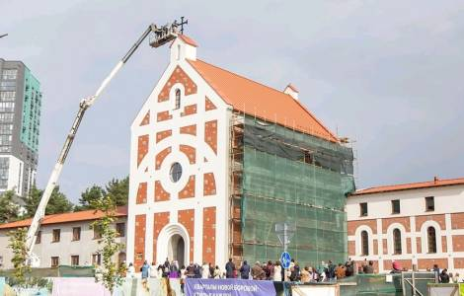
Musarrat Bibi, a mother of three, and Muhammad Sarmad, a gardener, were arrested on April 19 for allegedly burning pages of the Quran while cleaning a girl's school in a village in Punjab province. Bibi, illiterate and an office assistant at the school for more than a decade, was accused of burning the Quran, while Sarmad was accused of helping her with the cleaning up and burning of the waste. Both were released on bail on May 13.
20-5-23
Belarus - The new church of St. Francis of Assisi consecrated in Minsk
(20-5-23) The celebration of the consecration of the new parish church of Saint Francis of Assisi in Minsk, capital of Belarus, ended on Saturday May 20, at the end of the morning. The solemn liturgical concelebration, presided over by the Apostolic Nuncio in Belarus, Archbishop Ante Jozić, was attended by many bishops and took place in the presence of diplomatic representatives of various nations. "This new church - explains the parish priest, friar Jan Sadoŭski OFMCap - is important, because it is a sign that the Catholic community is alive, that it wants to grow and that it has a future.”
Togo - Catholics and Muslims together inaugurate the 'Msgr. Marion De Brésillac' medical and social center in the suburbs of Lomé
(20-5-23) "A few days ago we inaugurated the Ven. Marion De Brésillac Medical and Social Centre in Apessito in the large suburb of Lomé.
The Muslim village chief, the Iman, and the chief of the local police were present at the inauguration and underlined the collaboration between Catholics and Muslims for the common good", said Father Silvano Galli to Fides. "A few official documents are still missing, but the structure is open and operational", added the priest of the Society of African Missions who is attending the SMA Preparatory Seminar in Lomé.
The Centre will be directed by Sister Régine Bellamy, of the Missionary Congregation of Our Lady of the Apostles (NDA). The missionary will be joined by six health workers including a doctor, a midwife, a laboratory technician and a group of nurses who are already on site and ready to receive and treat patients.
Chad - "Where do the weapons come from?". The unsettling questions of Catholic associations and movements on the recent massacres in southern Chad
(20-5-23) "We demand an immediate end to the massacres and greater security for the populations of the whole country", says the Union of Catholic Lay Movements and Associations of Chad (Umalect, which brings together 11 organizations) in a declaration to the Chadian Episcopal Conference, at the end of a plenary session held on May 18, during which the recent massacres in Logon Oriental, in the south of the country, were discussed.
The last one took place on March 17 in the village of Makate, canton of Andoum, sub-prefecture of Laramanye, with a provisional toll of 11 dead and 10 injured. On May 8, 17 people, including an infant, were killed and several injured during an attack on a village in Beka sub-prefecture.
In support of the victims of the massacres in the province of Logone Oriental, a moment of prayer was organized on May 19, in the Isidore Bakanja parish of Walia Goré, in the 9th district of N'Djamena.
Pakistan - Two Christian teenagers in prison for alleged blasphemy, a Muslim religious killed
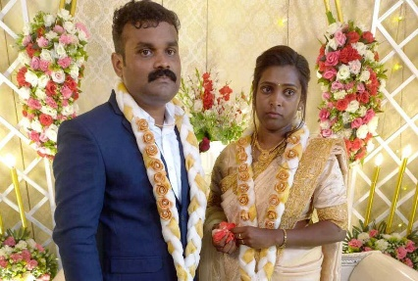
(20-5-23) Two Christian teenagers from Lahore, Adil Baber, 18, and Simon Nadeem, 12, were arrested and charged with "blasphemy" under article 295-C of the Penal Code on May 19, by order of the court. A police officer, Zahid Sohail, filed a complaint against them, saying he saw and heard them playing and calling a puppy dog "Muhammad Ali".
Both boys' families said they did not have a dog. Samina Nadeem, Simon's mother, explains that it was a misunderstanding, because the boys were talking about "Naswar" (a chewy paste, popular in Pakistan, ed) whose brand is called "Muhammad Ali". The policeman, who was passing by, started beating them and calling people out, accusing them of blasphemy. A first information report has been filed against the two boys. “The misuse of blasphemy is commonplace. The lives of Christians are under constant threat," says Nasir Saeed, of the CLAAS organization.
In recent weeks, a Muslim religious leader in the town of Mardan, in Khyber Pakthunkhwa province, Pakistan, was lynched by a mob after being accused of making a blasphemous allusion, during a demonstration, of former Prime Minister Imran Khan's party. Maulana Nigar Alam, 40, reportedly said, "Imran Khan is a sincere person and I respect him as the Prophet." This was considered blasphemy.

Endogamy forces Indian couple to marry outside closed church
(20-5-23) In a landmark move in the ongoing fight against endogamy in a southern Indian archdiocese, a couple garlanded each other in a customary marriage ritual and exchanged vows in front of a closed church.
As the groom’s parish priest defied a court order and refused him sacramental marriage, the ceremony was conducted outside the church before some 1,000 guests.
Groom Justin John, a member of Kottayam Knanaya Archdiocese that follows a strict tradition of endogamy, said his parish priest refused the permission because his bride Vijimol Shaji was from outside the archdiocese. The archdiocese refuses to solemnize the marriages if one party is from a non-Knanaya community.
Pope entrusts Cardinal Zuppi with Ukraine peace mission
(20-5-23) Pope Francis has entrusted Cardinal Matteo Zuppi, Archbishop of Bologna and President of the Italian Bishops' Conference, with the task of leading a mission to help ease tensions in the conflict in Ukraine. The Director of the Holy See Press Office, Matteo Bruni, confirmed the news of the mission on 20 May evening.
21-5-23
Pope: Jesus leads the way to heaven with His Ascension
(21-5-23) Addressing the gathering in Saint Peter's Square for the Regina Coeli prayer on this Sunday marking the Ascension of the Lord, Pope Francis reflected on two key aspects of this feast: why we celebrate Jesus' departure from the earth, and what He does now in heaven.
Remarking how "something new and beautiful happened," the Pope explained that with the Ascension, Jesus brought our humanity into heaven, as the humanity He assumed on earth "ascended into God" where it remains forever.
“We can say that from the day of the Ascension, God Himself, “changed” – from that point on, He is not only spirit, but such is His love for us that He bears our own flesh in Himself, our humanity!”
The Pope explained that with Jesus who has returned to the Father with our humanity, heaven is already a bit like our own place. Jesus has opened the way for us.
The second aspect the Pope focused on how Jesus in heaven is always there for us before the Father, continually showing our humanity to Him – the wounds He suffered for us. Jesus is our advocate before the Father, he explained, and therefore always with us "to the end of the age" to make intercession for us.
the Pope said our faith can help us not to lose hope or get discouraged, as Jesus intercedes for us before the Father.

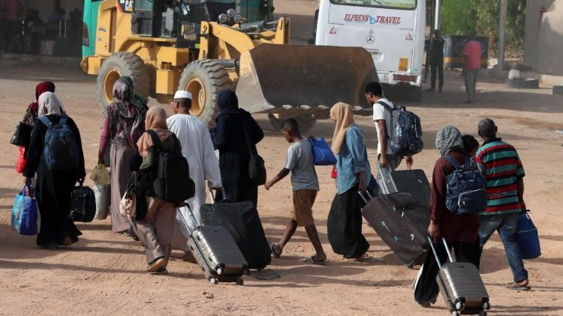
Pope Francis: Let us not get used to conflict and violence
(21-5-23) After the Regina Coeli prayer, Pope Francis issued “a heartfelt appeal” to warring factions in Sudan to lay down their arms, while calling on the international community “to spare no effort to ensure that dialogue might prevail and the suffering of the population might be alleviated.”
The Pope offered encouragement for the partial agreements that have already been reached, but noted that after a month of violence, the situation remains grave.
“Please, let us not get used to conflict and violence. Let us not get used to war!” the Pope pleaded.
Laudato Sí Week
(21-5-23) Pope Francis also noted the beginning of Laudato Sí Week, thanking those charged with preparing events and activities to mark the week. “I invite everyone to work together for the care of our common home,” he said, adding, “There is so much need to bring together expertise and creativity.”
New ceasefire in Sudan to begin Monday
(21-5-23) A provisional ceasefire has been agreed in Sudan which will take effect from sunset on Monday, 22 May. Though previous ceasefires have fallen apart quickly, it is hoped this latest seven-day pause in the violence will last.
---------------------------------------------------------------------------------------------------------------------------------------

