CATHOLIC WORLD LAST WEEK
(CWLW)
12-18 June 2023
12-6-23
Papal peace envoy for Ukraine says aim is dialogue, not mediation
(12-6-23) Cardinal Matteo Zuppi of Bologna discussed his role as papal envoy in an effort to lay the groundwork for a ceasefire in Ukraine.
Biden ‘hijacks’ foreign aid to push abortion, Congressman charges
(12-6-23) US President Joe Biden has “hijacked” a foreign-aid programme to promote abortion in Africa, according to a pro-life Congressman.
Rep. Chris Smith, a Republican from New Jersey, says that the PEPFAR program—begun in 2003 to fight AIDS—is now being used, particularly in African countries, “in order to promote abortion on demand.”
Year of parish Eucharistic revival begins in US
(12-6-23) Following a year of diocesan revival, the US bishops’ National Eucharistic Revival began a year of parish revival on June 11, the Feast of Corpus Christi. The National Eucharistic Revival culminates in a National Eucharistic Congress in Indianapolis in June 2024.
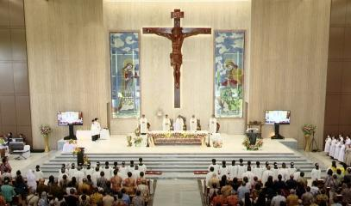
New Indonesian church consecrated after 26 years of struggle
(12-6-23) Indonesian Catholics in the district of Pinang celebrated the consecration of a new parish church, which was consecrated after a 26-year battle with local authorities.
St. Bernadette parish fought through active opposition from Muslim activists, and stalling from local public officials, to obtain permission to build the new church. Remarking that the struggle “reflects our endurance,” Cardinal Ignatius Suharyo of Jakarta said: “May it boost our Christian faith and generate many benefits for the people.”
Pope offers condolences on death of former Italian premier Berlusconi
(12-6-23) Pope Francis has offered his condolences to the family of Italy’s former Prime Minister Silvio Berlusconi, who died on June 12 at the age of 86.
In a telegram to the late politician’s daughter, Cardinal Pietro Parolin, the Secretary of State, said that the Pope saw Berlusconi as “a key figure in Italian politics, who held public responsibilities with an energetic temperament.” He assured the family of his “fervent remembrance in prayer.”
Hundreds attend AI-generated Lutheran service in Bavaria
(12-6-23) ChatGPT generated almost the entire 40-minute service, which took place on June 9 in Fuerth as part of a German Protestant church convention.
DR Congo - "We are blessed because Jesus gives us his flesh". Cardinal Tagle celebrates the closing Mass of the National Eucharistic Congress
(12-6-23) Christ himself "promised to dwell in those who will receive his body and his blood: a promise and gift of his presence". And "His presence is active and dynamic. His presence makes us a new creation". Thus, Cardinal Luis Antonio Tagle, Pro-Prefect of the Dicastery for Evangelization and the special Papal Envoy to the third National Eucharistic Congress, indicated the Sacrament of the Eucharist as the food that assimilates poor human creatures to Christ, who became flesh to give them salvation and happiness. He said this while presiding over the closing Eucharistic liturgy of the National Eucharistic Congress held in Lumumbashi, Democratic Republic of the Congo, from June 4 to 11. "We are blessed", said Cardinal Tagle "because Jesus gives us his flesh".
On Sunday, June 11, the day the Catholic Church celebrated the solemnity of Corpus Christi, the Cardinal said, "There are cravings," the Cardinal acknowledged, "that subjugate people and make them drink from the sources of greed, corruption and manipulation: we have an appetite for the latest fashion, the latest cell phone and the latest weapon or rocket. We have fed too much on anger, jealousy and competitiveness. And the food and drink these cravings drive us to will sicken us, our families, and our world. They will make the poor even poorer". To eat the body of Christ given for us "is instead to feed us out of his humility, generosity and love. To drink His blood shed for us is to quench our thirst with His mercy, justice and forgiveness. To live from the Word of God made flesh and blood means to live as he lived, always in filial communion with God and always in fraternal communion with his brothers and sisters, especially with the weakest and forgotten".
Sudan - Violent fighting in Khartoum after the end of the 24-hour truce
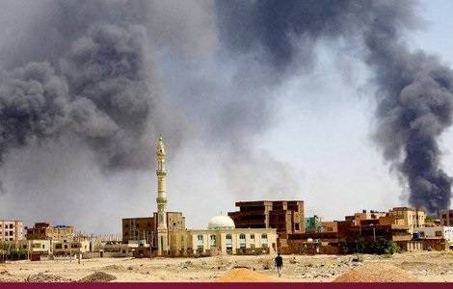
(12-6-23) Fighting in the Sudanese capital, Khartoum, resumed immediately after the end of the 24-hour ceasefire at 6 am on Sunday morning, June 11th.
Clashes between Sudanese Army soldiers (SAF) and the militiamen of the Rapid Support Force (RSF) are concentrated in the south and centre of Khartoum, and in Shambat along the Nile, Haj Youssef in Bahri up to the strategic Halfiya bridge, which crosses Omdurman. The densely populated neighborhood of Haj Youssef in Bahri, one of three adjacent cities that together with Khartoum and Omdurman form the capital at the confluence of the Nile.
On Friday, June 9, on the eve of the 24-hour ceasefire, the two factions clashed in northwest Omdurman. According to local sources, Sudanese forces advanced on multiple axes into Khartoum on Sunday, June 11, after the end of the 24-hour ceasefire.
The ceasefire enabled relief materials to reach the war-affected.
Pakistan - The path of legality to promote the rights of all citizens and work to combat any discrimination
(12-6-23) While regretting that even after nine years of the Supreme Court of Pakistan’s expression of serious concerns about the failure of the federal and provincial governments to protect the human rights of the non-Muslim citizens (specially Christians and Hindus), have not been addressed, the Centre for Social Justice (CSJ) has released a report with suggestion for rectification..
"Quest for Justice", the report of CSJ, whose president if Peter Jacob, a Catholic, examines court cases and executive branch executive orders and assesses whether government actions are consistent with Supreme Court orders. "It is disappointing - says Jacob - the fact that governments have not complied with the 2014 ruling: today we are asking the government to approve a bill to set up a national legal Commission for minority rights". This will help combat aby discrimination, CSJ says.
Haiti - The consequences of climate change hit Haiti: Missionaries report on the difficult everyday life of the people
(12-6-23) Global climate change continues to claim victims in the Caribbean island of Haiti. After more than a year of insecurity, fear, hunger, starvation and despair, in these hours Camillian missionaries from Port-au-Prince report floods and landslides after a river in Croix des Missions, on the outskirts of the capital, has overflowed its banks. More than 50 victims have been counted and there are 140 injured and missing and tens of thousands homeless.
Heavy rains hit seven of Haiti's ten departments, forcing thousands of families to flee their homes. In total, more than 37,000 people were affected and nearly 32,000 homes were flooded. The number of people affected is reportedly set to get worse as thousands of families are in dire need of food, drinking water and medicine.
Another earthquake of magnitude 5.5, which was registered on the night of June 6th and which, according to the first estimates, killed four people, injured many people and caused countless collapses, has further aggravated the situation of the population, the missionaries from Jeremie report. The June 6 earthquake was the second in just two days in the region.
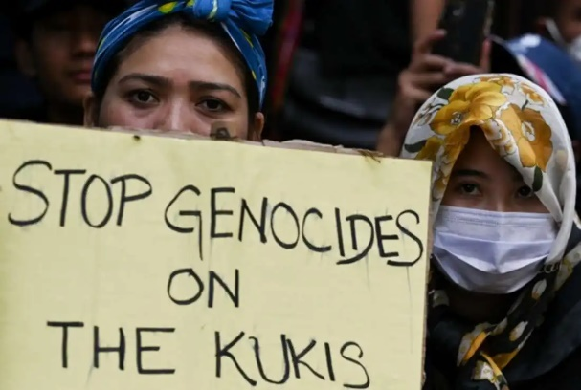
Meanwhile, gang robberies, extrajudicial executions, kidnappings and gender-based violence are part of everyday life in Haiti, forcing local residents to flee their homes, according to the recently published report of the United Nations Integrated Office in Haiti. In addition to the gangs, the activities of vigilante groups are also the cause of a large number of lynchings. More than 1,630 people were killed, injured or kidnapped in the first three months of 2023, a 30 percent increase from the previous quarter. It is estimated that almost half of the Haitian population - around 5.2 million people - are in need of humanitarian assistance.

$12 million relief package for India’s riot-hit Manipur
(12-6-23) India’s pro-Hindu federal government has announced a relief package worth US$12 million for the strife-torn northeastern Manipur state where riots between the predominantly Hindu Meitei community and tribal Christians claimed 98 lives and damaged homes and churches.
The federal government has approved a sum of 1 billion Indian rupees (some US$12.5 million) for providing "relief to the internally displaced people in the state,” Kuldiep Singh, security advisor for the Manipur government, said in a press statement in Imphal, the capital of the hilly state. Singh indicated that Manipur, bordering the civil war-hit Myanmar, is limping back to normalcy after a month-long violence, saying on June 8, “Manipur is currently in a state of peace” as there were “no fresh reports of any acts of violence within the state for the past 48 hours.” The state government, also led by the pro-Hindu Bharatiya Janata Party, has not withdrawn law and order measures, including a curfew.
The unprecedented violence started in Manipur on May 3 between the ethnic Kuki and Meitei communities over a court proposal to give special tribal status as a “Scheduled Tribe” group to Meitei people under India’s affirmative action programme to enable them special benefits such as seats in government jobs and educational institutions. Most Kuki tribe people are Christians, while a majority of Meiteis are Hindus, though a few of them are Christians, too.
Nationwide support for minority Christians has been growing. Nearly 35 bishops, including Eastern rite Cardinals George Alencherry and Baselios Cleemis, joined a candlelight procession and a special prayer gathering in solidarity with the victims on June 7 in Kerala, the headquarters of their Churches in communion with Rome.
The cardinals gathered at the Basilica of Our Lady of Vallarpadam, a renowned pilgrimage centre under the Latin rite Verapoly archdiocese in Kerala.

Winds, heavy rains kill at least 27 in Pakistan
(12-6-23) Heavy rains followed by strong winds killed at least 27 people, including eight children, in northwest Pakistan, officials said 11 June Sunday.
The storms hit four districts of Khyber Pakhtunkhwa province late Saturday, with five siblings aged between two and 11 among the dead. "At least 12 people were buried alive after the roofs and walls of their houses collapsed," Taimur Ali Khan, a spokesman for the provincial disaster management authority, told AFP. More than 140 people were injured and more than 200 livestock died, he said.

Bangladesh Hindus live in fear after attacks
(12-6-23) Three incidents of attacks on members of Bangladesh’s minority Hindu community last week have left one dead and four injured, just days after its leaders gathered in the national capital Dhaka and expressed fears about a potential upsurge in violence against them ahead of national polls next January.
“We live in an area where the simplest of reasons could end lives. We are conscious of it every moment, trying to avoid picking up a fight with the majority Muslims,” said Prano Das, younger brother of the murdered fisherman, Dulal Das, 50, from Rajganj in Naokhali district in southeastern Bangladesh. Noakhali is a coastal district that has a history of Islamist fanaticism. The district witnessed deadly riots that saw Hindus attacked, massacred, raped and Hindu properties looted and set ablaze in 1946 when Bangladesh was part of British India.
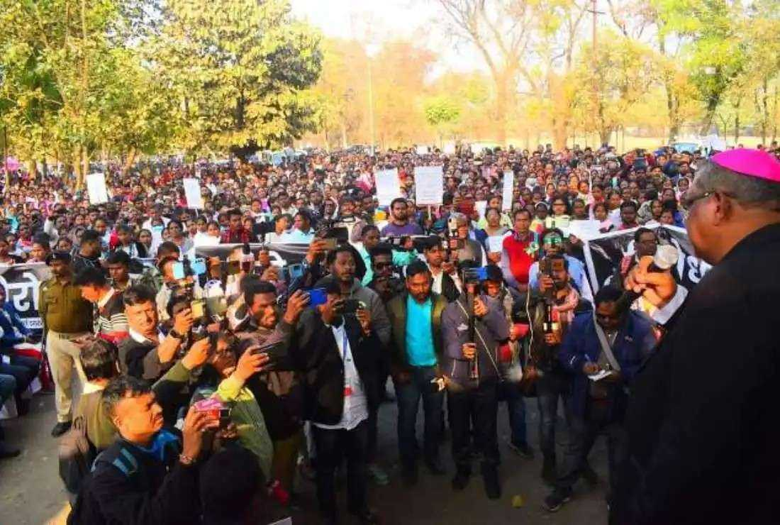
The Bangladesh Hindu-Buddhist-Christian Unity Council in a June 10 statement said such murders are hard to accept in a democratic country. Hindus account for 8 percent of Bangladesh’s more than 165 million people, according to the 2022 national census.

Tribal Christians protest in poll-bound Indian state
(12-6-23) Tribal Christians in a poll-bound central Indian state have protested against a call to de-list them from India’s affirmative action programme and deny them reservation benefits.
Hundreds of tribal Christians on June 10 marched through Raipur, Chhattisgarh state capital, six months ahead of the state elections. They shouted slogans against some Hindu groups' demand to remove tribal Christians from the list of people receiving reservation benefits in jobs and educational institutions. Tribal groups, listed as Scheduled tribes, receive such benefits as part of affirmative action to bring them social mainstream.
Certain Hindu groups say tribal people who have become Christians should not be given such benefits as they have left traditional tribal customs and faith. Clad in their traditional attire, the Christian tribals gathered at the Science College ground under the banner of the Chhattisgarh Christian Adivasi Mahasabha (Chhattisgarh Christian tribal forum).
In April this year, the Janjati Suraksha Manch (tribal protection forum) organized a rally in Raipur, demanding that tribal people, “who do not follow the traditions and customs, should be removed from the benefits meant for the Scheduled Tribe (ST) community." Nearly 98.3 percent of Chhattisgarh’s 23 million people are Hindus. Muslims account for 1 percent and Christians, mostly tribal people, account for 0.7 percent.
If tribal Christians are delisted, they lose the benefits which are meant “to uplift their socio-economic condition,” Father Nicholas Barla, secretary of the Catholic Bishops’ Conference of India (CBCI) Commission for Tribal Affairs, told UCA News on June 12. Delisting tribal people who converted to other religions has assumed political significance as some of the tribal majority regions like the entire northern belt of Sarguja voted en masse for the opposition Congress in the 2018 assembly elections, forcing the current ruling pro-Hindu Bharatiya Janata Party (BJP) to draw a blank.
With the next assembly elections at the end of this year, there is a move towards delisting of converted tribal people to lift the poll prospects of the ruling party.
13-6-23
Be mindful of the poor, ready to act, Pope urges
(13-6-23) In his statement for the 7th World Day of the Poor, which will be observed on November 19, Pope Francis writes: “We are living in times that are not particularly sensitive to the needs of the poor.”
“The poor become a film clip that can affect us for a moment, yet when we encounter them in flesh and blood on our streets, we are annoyed and look the other way,” the Pope writes.
While “there is a need to urge and even pressure public institutions to perform their duties” toward the poor, the Pope emphasizes that “it is of no use to wait passively” for government action. He exhorts all believers to be mindful of those who are poor, and ready to help. “May our concern for the poor always be marked by Gospel realism,” the Pontiff adds. “Our sharing should meet the concrete needs of the other, rather than being just a means of ridding ourselves of superfluous goods.”
Pope: End ‘scourge of child labour’
(13-6-23) “Many children, instead of receiving a good education, are exploited, subjected to slave labor,” Pope Francis tweeted on June 12, the World Day Against Child Labor. “No effort should be spared to end the scourge of child labor! Children are our hope. Let us not allow that hope to be stifled!”
Vatican court convicts climate activists for damaging statue, fines them more than $30K (AP)
(13-6-23) Last August, climate protestors glued their hands to the base of Laocoön and His Sons, an ancient Roman statue displayed at the Vatican Museums. Vatican prosecutor Catia Summaria sought prison sentences and small fines, but the court opted for larger fines and suspended sentences.
Catholic priest testifies before European Parliament about religious repression in Belarus
(13-6-23) Belarus, an Eastern European nation of 9.4 million, is 80% Christian (65% Orthodox, 12% Catholic). Alexander Lukashenko, known for his repressive rule, has been the nation’s president since 1994.
Nigerian diocese appeals for ‘intense prayers’ for abducted priest
(13-6-23) Father Jeremiah Yakubu was kidnapped from his parish’s rectory on June 11, according to the report. Father Yakubu ministers in the Diocese of Kafanchan, in Nigeria’s Kaduna State.
In Peru, Latin American religious address persecution, abuse, synod
The Confederación Latinoamericana de Religiosos (Latin American Confederation of Religious) concluded a four-day meeting in Lima, Peru, by issuing a Spanish-language message.
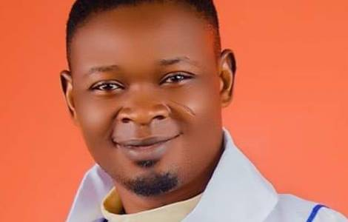
Nigeria - In the north of the country: Another Catholic priest kidnapped and released
(13-6-23) The Catholic priest Jeremiah Yakubu was the victim of another kidnapping in Nigeria, late on Sunday evening, June 11, by gunmen from the rectory of the Holy Trinity Parish in Karku, Kauru Local Government Area, Kaduna State, and was released last night, June 12th.
Unlike the recent kidnappings of priests that occurred in southern Nigeria, this recent kidnapping in Kaduna state took place in a Muslim-majority area in the north. However, the fact that a large number of kidnappings by priests in the South occur in Christian-majority areas suggests that most kidnappers are criminally motivated rather than religiously motivated.
Sudan - RSF militiamen are consolidating positions on the Central African border
(13-6-23) As fighting continues in the Sudanese capital Khartoum, in Darfur, the Rapid Support Forces (RSF) militiamen, led by Mohamad Hamdan Dagalo (known as "Hemedti") consolidate their control of the border with the Central African Republic.
The RSF have announced that they have taken control of Um Dafog, a small town on the border between Sudan and the Central African Republic, and have captured 125 soldiers of the SAF (the regular army), who are said to have surrendered without a fight. The capture of Um Dafog is not particularly surprising given the
RSF's political and military dominance in South Darfur and neighboring eastern Central African Republic, where it controls the gold mining industry, which is its main source of funding.
The conflict between the Sudanese army led by General Abdel Fattah al-Burhane and the RSF led by "Hemedti" seems increasingly focused on taking control of the opponent's resources and/or defending one's own. By securing control of the border with Central Africa, the RSF is strengthening ties with its bases in that country and, most importantly, protecting the supply and export corridors of Sudan's gold mines (although the RSF is also said to control Central African gold mines). At the same time, in the capital, the RSF are besieging the army's ammunition factory in Yarmouk.
DR Congo - Cardinal Tagle to the Church of Goma: you are in the heart of Pope Francis
(13-6-23) Even in the martyred region of North Kivu, the disciples of Jesus are called above all to offer to all the "wonderful flavour" and light of Jesus and his gospel. Flavour and light that "do not come from us", but from Jesus who works in us through the Holy Spirit", said Cardinal Luis Antonio Tagle, Pro-Prefect of the Dicastery for Evangelization, who during his trip to Africa also visited the Democratic Republic of the Congo, during a Mass in Goma (North Kivu), briefly outlined the mission of hope and rebirth entrusted to the baptized even in places affected by conflicts, violence and collective disasters. During his homily at the Mass he celebrated on the Feast of St. Anthony of Padua on Tuesday, June 13, at the Church of Our Lady of Mount Carmel (where a multitude of people watched the service from the screens set up around the church persecuted), Cardinal Tagle made an appeal for peace and reconciliation to the entire Church of Goma and conveyed the greetings of Pope Francis. The Pope – Cardinal Tagle recalled – wanted to visit Goma on his recent apostolic journey to the Democratic Republic of Congo, "to show you his closeness. He suffered much for not being here. But rest assured that you are in his mind and in his heart."
Vietnam - Divorce rate rising: Tendency less pronounced among Catholics
(13-6-23) More and more young couples in Vietnam are getting divorced. This is confirmed by the latest statistics and sociological studies. The country's divorce rate has nearly doubled over the past 10 years, from 1% in 2009 to 1.8% in 2019.
sociologist Nguyen Anh Hong has said, "The phenomenon of young people getting married and soon getting divorced is a matter of serious concern in our culture and society". According to the Institute of Family and Gender Research, Vietnam averages more than 60,000 divorce cases annually as of 2018, accounting for 30 percent of the total number of couples who get married – the reasons for break-down of marriages being: conflicts in the lifestyle, adultery, economic factors, domestic violence health reasons.
Meanwhile, in the Catholic community in Vietnam (around 9 million believers out of a population of 97 million), this trend is less pronounced. In the process of conflict resolution, the Christian faith plays an important role: sharing moral and religious values leads the spouses to take positive action to improve relationships and refrain from extreme solutions, says Cu Thi Thanh Thuy, Vietnamese scholar and researcher.
Indonesian court jails three Papuans for treason
(13-6-23) An Indonesian court has sentenced three Papuans to jail for treason after they held a worship service to commemorate the 11th anniversary of the Papua separatist movement.
Judges at the Makassar District Court in South Sulawesi province sentenced Hellesvred Bezaliel Soleman Waropen, 54, Andreas Sanggenafa, 64, and Kostan Karlos Bonay, 57, to two years in prison on June 12.
The judge stated that the accused were legally and convincingly proven guilty of committing the crime of "treason." They held a meeting on the 11th anniversary of the Federal Republic of West Papua, considered a separatist movement by the Indonesian government, in Manokwari, West Papua province, on Oct. 19, 2022.
Philippine villagers flee as volcano spews lava
(13-6-23) At least 14,000 Filipinos have fled their homes in the Bicol region, south of Luzon, after the country’s most active volcano spewed lava and noxious gases, authorities said.
The Mayon volcano, also known as the world’s perfect cone, began spewing ashes on June 8 and lava is now seen flowing at the volcano’s crater together with occasional earth tremors.
People who fled their homes since June 12 may have to extend their stay inside the classrooms and basketball courts as the Philippine volcanic experts expect the ongoing eruption to continue for several months. The people evacuated from their homes are having a tough time inside the overcrowded evacuation centers.
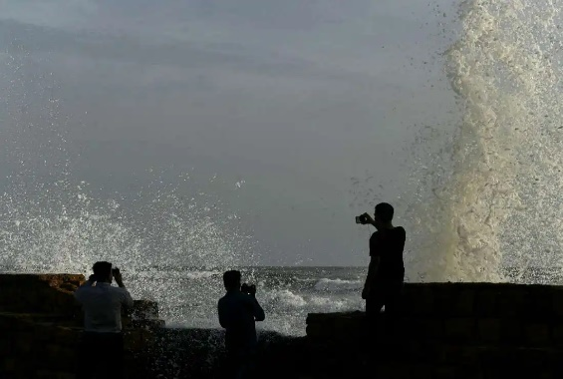
The Diocese of Legazpi has been giving food packs and relief goods to thousands of residents sheltered inside government schools and basketball courts. Parishes in the region have been sending their Sunday collections to ensure food for the evacuees.

Mass evacuations as cyclone heads to Pakistan
(13-6-23) Pakistan authorities began an evacuation effort on 12 June to move 80,000 citizens out of the path of an approaching cyclone, which is expected to bring winds of up to 120 kilometres per hour.
The cyclone is making its way across the Arabian Sea towards the coastlines of Pakistan and India, forecast to make landfall later this week.
Swathes of coastal communities in southern Sindh province are set to suffer storm surges up to 3.5 metres (12 feet), which could inundate low-lying settlements, as well as up to 30 centimetres of rain.
The Pakistan Meteorological Department has warned that traditional mud and straw homes which house the poorest in Pakistan will be vulnerable to disintegration in high winds.
Karachi -- a port city home to around 20 million -- is also due to be deluged by dust and thunder storms with winds whipping up to 80 kilometres per hour.
India's Meteorological Department said on 12 June the storm will hit western Gujarat state around noon on 14 June, with winds gusting up to 150 kilometres per hour causing "total destruction of thatched houses".
14-6-23
Russia is guilty of ‘ecocide’ as well as genocide, Ukrainian Catholic leader charges
(14-6-23) Major Archbishop Sviatoslav Shevchuk, the head of the Ukrainian Greek Catholic Church, lamented the damage wrought by the destruction of the Kakhovka Dam.
“Do not be afraid to tell the truth about the crime of the Russians, which caused such a great disaster to man and God’s creation,” he said to the international community.
“But the enemy fails to demoralize us,” he added. “Ukrainians are uniting more and more, collaborating, and helping each other. And today, I want the world to hear again: Ukraine stands, Ukraine fights, Ukraine prays.”
Satellite with Pope’s words launched into space
(14-6-23) Students at the Polytechnic University of Turin built the satellite, called Spei Satelles (Satellite of Hope); the Italian Space Agency is operating it.
Pope’s recovery continues: blood tests good
(14-6-23) “The Holy Father rested well during the night,” Matteo Bruni, director of the Holy See Press Office, said on June 13. “The results of the blood tests he underwent were normal; he is continuing his respiratory therapy.”
Pro-life agency in Rome vandalized by LGBT marchers
(14-6-23) The office of the Pro Vita & Famiglia organization in Rome was vandalized by participants in a Pride March on June 10.
Marchers shouted insults as they passed the building, and some painted slogans (“Fascists should be hanged” and “transfeminist revenge” on the gate. The building was also pelted with eggs.
Italian Christian leaders discuss challenges in proclaiming the Gospel
(14-6-23) Representatives of 17 churches and ecclesial communities in Italy met for the first time on June 12 as part of the Italian synodal process.
Bishop Derio Olivero, president of the episcopal commission for ecumenism and dialogue, described the meeting as a “historic event.”
Participants in the meeting, which took place at the headquarters of the Italian Episcopal Conference, discussed challenges to the proclamation of the Gospel in Italy, challenges to Christianity, and how the Spirit is calling the different Christian bodies to live together.
The poor ‘desire our closeness and sense of humanity,’ Vatican bishop says of papal message
(14-6-23) Archbishop Rino Fisichella, pro-prefect for the Section of New Evangelization of the Dicastery for Evangelization, commented on the Pope’s message for the World Day of the Poor.
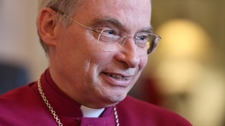
Retired Anglican bishop to enter Catholic ordinariate
(14-6-23) Anglican Bishop Richard Pain, who retired in 2019 as head of the Diocese of Monmouth, Wales, will enter the Catholic Church in July, becoming a member of the Anglican ordinariate of Our Lady of Walshingham.
Sudan - The war in Sudan worsens: ethnic violence reported in Darfur
(14-6-23) The situation in West Darfur, the western region of Sudan which, together with the capital Khartoum, the epicenter of the fighting between soldiers of the Sudanese regular army and the militiamen of the Rapid Support Forces (RSF) is dramatic. The heaviest fighting is concentrated in El Geneina, the capital of West Darfur, which has been under siege and constant fire by the RSF since fighting broke out on April 15.
The conflict has taken on an ethnic dimension, at least in this part of the country, with clashes between members of the Masalit people and Arab tribes (who form the majority of the ranks of the RSF). A situation denounced by the UN envoy to Sudan, Volker Perthes: "As the situation in Darfur continues to deteriorate, I am particularly concerned about the situation in El-Geneina (West Darfur), where the violence has assumed ethnic proportions", he said in a statement.
"Massive attacks on civilians because of their ethnic origin, allegedly by Arab militias and gunmen wearing RSF uniforms, are deeply worrying and, if true, could constitute crimes against humanity," he warned.
Middle East - After the earthquake, the Arab countries re-embrace the "pariah nation": The end of Syria's isolation as seen by the Holy See
(14-6-23) Ravaged by over a decade of war, compounded by poverty and a pandemic, more persecution arrived on February 6 when earthquakes killed some 6,000 people living near the country’s northwest border with Turkey and displaced over 330,000
Aleppo, the region’s largest city, has long been a center of Christianity.
But sudden disaster made Syria the focal point of special concern especially from its neighbors—including Saudi Arabia, accused of helping foment insurgency against President Bashar al-Asaad by supplying Syrian rebels with arms.
As a direct result of the humanitarian crisis, the 22-nation Arab League ended Syria’s regional isolation: Asaad was personally welcomed at the League’s meeting in Jeddah, Saudi Arabia last month, where he addressed the organization, which evicted him 12 years ago.
It’s a startling, positive development which can also be welcomed by the Holy See, even as the Holy See urges the West to step up and end sanctions crippling Syria’s economy.
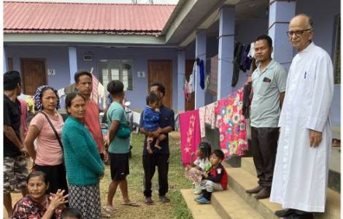
India - Interreligious appeal in Manipur: put an end to violence and assist the victims
(14-6-23) It is necessary to stop the spiral of violence, which is harmful and leaves deep wounds, both physical and moral; provide protection and care to victims; begin a process and a period of reconciliation and examine the demands of the Kuki and Meitei ethnic communities concerned. This is what religious representatives demanded at the meeting of the "Manipur Cultural Integration Council" in the city of Imphal, the capital of the Indian state of Manipur in northwestern India.
A total of 18 representatives of religious communities including Muslims, Christians, Buddhists and representatives of local and traditional cults attending the meeting issued a heartfelt appeal to put an end to the ongoing violence in Manipur and "further joint initiatives in cooperation with civil and religious institutions and help the victims of violence". The text calls for "the provision of medical assistance and healing and care to all those who have been affected by the wave of violence in Manipur" and expressly invites all faith communities to "participate, directly contribute and contribute to reconciliation".
Haiti - General Crisis and Cholera Epidemic: Viatorian missionaries accompany people with faith and determination
(14-6-23) "Every day brings new suffering. Unfortunately, for years, when one speaks of Haiti, one thinks of a country in disaster: economic, ecological, political, demographic...", said Father Nestor Fils-Aimé, Provincial Superior of Canada of the Clerics of Saint Viator (CSV), told Fides. "Unfortunately, every time one talks about this country, even though it is rich in natural and human resources and with a beautiful history, crises, emergencies and violence are denounced". The missionary referred in particular to the recent events of this week in June, when the country was hit by landslides, floods and repeated earthquakes and is currently experiencing a renewed increase in cholera cases.
"It is a great challenge for us," emphasizes Father Fils-Aimé, "we always dream of improvement, but it is slow to come. However, we remain optimistic and continue to act with the same faith and determination to create spaces of light, of joy and hope".
Indian pastor, associate get bail in conversion case
(14-6-23) A court in a central Indian state has granted bail to a pastor and his female associate 10 days after they were arrested on charges of religious conversion under the sweeping anti-conversion law.
A sessions court in Satna district in Madhya Pradesh on June 13 granted bail to pastor Mayaram Ningwal and his companion Aarti Saket.
But pastor Roshan Faster, who was arrested along with pastor Ningwal on June 4, is yet to be released from jail, Christian activist Minakshi Singh told UCA News on June 14.
Singh, general secretary of Unity in Compassion, a charity based in neighboring Uttar Pradesh, said that the bail pleas of all three persons were rejected on June 6 but two of them secured it on June 13.
They are charged with the Madhya Pradesh Freedom of Religion Act, 2021 after the Bajrang Dal (warriors of Lord Hanuman), a hardline Hindu outfit, disrupted a prayer service held in a house owned by Saket, a resident of Motwa village in Satna district, alleging they were involved in conversion activities. Singh said that “atrocities against Christians are mostly reported from the pro-Hindu Bharatiya Janata Party (BJP)-run governments who often accuse Christian missionaries of religious conversion.”
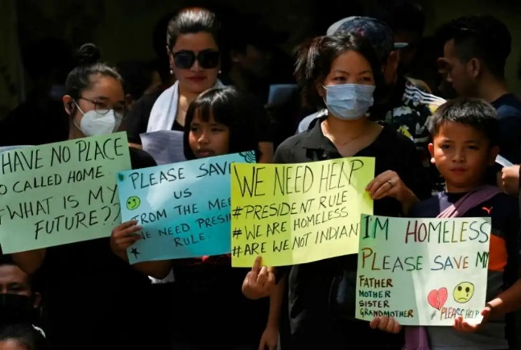
Indian archdiocese to help Manipur students
(14-6-23) Bangalore archdiocese in southern India’s Karanataka State has shown a willingness to rebuild the shattered lives of college and school-going students from the strife-torn hilly state of Manipur, where a fresh outbreak of violence has reportedly resulted in the killing of 11 more people.
Archbishop Peter Machado of Bangalore welcomed nearly 70 students from the northeastern state at the archdiocesan pastoral centre on June 12.
“We will provide all-round help,” the archbishop said trying to console and assure them of all support. Archbishop Machado assured them that they could continue their studies in “diocesan and religious order-run institutions free of cost.”
He expressed “solidarity with displaced people of Manipur” and conveyed his readiness to help them, according to a press release.

HK court adjourns case seeking protest song ban
(14-6-23) A Hong Kong court has adjourned a hearing on a government application seeking a ban on a pro-democracy protest song called Glory to Hong Kong.
Judge Wilson Chan of the Court of First Instance on Monday adjourned the hearing on the application from the Department of Justice (DOJ) for an interim injunction on the song until July 21, Hong Kong Free Press (HKFP) reported on June 12.
The department’s lawyer said the injunction was aimed at people who “are conducting or intending to conduct” the distribution of the song with the intention of inciting secession, sedition, or to violate the national anthem law.
15-6-23
Pope Francis directs Archbishop Gänswein to return to diocese of origin
(15-6-23) “On 28 February 2023, Archbishop Georg Gänswein concluded his office as Prefect of the Papal Household,” the Holy See Press Office announced on June 15. “The Holy Father has directed Archbishop Gänswein to return to his home diocese for the time being.”
Pope Benedict named Gänswein the Prefect of the Papal Household in December 2012 and consecrated him a bishop in January 2013—a month before the late Pope’s shocking resignation.
In 2020, Pope Francis reduced Archbishop Gänswein’s duties as Prefect of the Papal Household. The reduction in his role came shortly after he was caught in the middle of a controversy over the publication of a book defending the tradition of priestly celibacy.
Pope to be discharged from hospital Friday
(15-6-23) Pope Francis will be released from Gemelli Hospital on Friday morning, the Vatican has announced.
“The medical staff reports that the clinical course is proceeding regularly, without complications, and therefore they are planning his discharge for the next few days,” Matteo Bruni, director of the Holy See Press Office, said on June 14, one week after the Pope underwent abdominal surgery at Agostino Gemelli University Policlinic in Rome. The next day the Vatican announced that the Pope’s discharge had been scheduled.
The Pontiff will continue his recovery under the care of his medical team at the Vatican.
‘Move away from the logic of the legitimacy of war,’ Pope tells UN Security Council
(15-6-23) In a June 14 message to the UN Security Council, Pope Francis called for peace and spoke of a “famine of fraternity.” Archbishop Paul Richard Gallagher, the Holy See’s Secretary for Relations with States and International Organizations, read out the message for the hospitalized Pope.
“In order to make peace a reality, we must move away from the logic of the legitimacy of war: if this were valid in earlier times, when wars were more limited in scope, in our own day, with nuclear weapons and those of mass destruction, the battlefield has become practically unlimited, and the effects potentially catastrophic,” Pope Francis wrote.
“The time has come to say an emphatic ‘no’ to war, to state that wars are not just, but only peace is just: a stable and lasting peace, built not on the precarious balance of deterrence, but on the fraternity that unites us,” he continued.
Ahmed al-Tayeb, the Grand Imam of Al-Azhar, also addressed the Security Council and called for peace. The Pope and the Grand Imam signed the Document on Human Fraternity in the United Arab Emirates in 2019.
Pope stresses bond between elderly, young people
(15-6-23) In a statement for the 3rd World Day for Grandparents and the Elderly, Pope Francis says:
God wants young people to bring joy to the hearts of the elderly, as Mary did to Elizabeth, and gain wisdom from their experiences. Yet, above all, the Lord wants us not to abandon the elderly or to push them to the margins of life, as tragically happens all too often in our time.
Following up on the papal statement, the Dicastery for Laity, Family, and Life recommended that all Catholic dioceses and parishes schedule “a solemn Eucharistic celebration together with grandparents and the elderly” and ask young people to visit the elderly on Sunday, July 23— the date for the World Day for Grandparents and the Elderly. The Dicastery also suggested that the elderly pray for young people on World Youth Day, which will open in Lisbon that week.
Southern Baptist Convention affirms only men may serve as pastors
(15-6-23) The Southern Baptist Convention, the nation’s largest Protestant denomination, has affirmed that “while both men and women are gifted for service in the church, the office of pastor/elder/overseer is limited to men as qualified by Scripture”—or, in the words of the AP headline, “Southern Baptists refuse to take back megachurch because it has women pastors.”
Jubilee announced for Sacred Heart apparitions to St. Margaret Mary Alacoque
(15-6-23) Bishop Benoît Rivière of Autun (France) has announced a jubilee to commemorate the 350th anniversary of the apparitions of the Sacred Heart of Jesus to St. Margaret Mary Alacoque in Paray-le-Monial.
The jubilee will begin on December 27, the anniversary of the first apparition, and will conclude on the Feast of the Sacred Heart in 2025. The jubilee’s theme is “render love for love.”
Somalia - People flee Las Anod: "We have nothing to eat, the only thing we get is water"
(15-6-23) The clashes between the security forces of separatist Somaliland, who have been occupying the city of Las Anod in the north of the country since 2007, and the militias of the local clans, who are demanding secession and direct administration by the Somali government in Mogadishu, have escalated since February last year.
Hundreds of thousands of people, who fled the fighting in the disputed Somali city, are stranded in the countryside affected by drought.
According to local sources, as of February 2023, more than 200,000 people, mostly women, children and the elderly, had fled Las Anod to surrounding villages, seeking refuge in an area already hit by five consecutive droughts. Another 100,000 people crossed the border into neighboring Ethiopia, where aid organizations are reporting a desperate situation in which many children under the age of five and pregnant and nursing mothers are suffering from moderate acute malnutrition.
Most of those who fled the violence have settled in informal camps such as that in Kalabaydh, or have been taken in by local villages already suffering the effects of a severe drought that has decimated livestock, the basis of the local economy. "We have nothing to eat, the only thing we can get is water", reported the refugees who arrived in Kalabaydh, a town that had a population of about 7,000 before the bombing and is now home to about 30,000 refugees who also live in the surrounding areas.
Sri Lanka - Economy is recovering: Catholic communities remain in solidarity even after the crisis
(15-6-23) Sri Lanka is on the way out of the worst economic crisis in decades that hit the country last year when its foreign exchange reserves ran out and the country went into default. The drastic measures taken by the government included import restrictions on more than 3,200 items, while it recently lifted import restrictions on 286 items. Over the past nine months, financial conditions have improved and the economy has regained some stability. Despite the easing of the crisis, the country needs to complete debt negotiations with creditors by September and implement important economic reforms to put the recovery on a sustainable path.
The national director of the Pontifical Mission Societies on the island of the Indian subcontinent, Fr. Basil Rohan Fernando, priest of the Archdiocese of Colombo, says that this change has not yet had direct effects on people's lives, given the essential consumer goods are still at very high prices, which puts thousands of families in difficulty. For example, the cost of electricity has risen 200% since last year and continues unabated. The loss of jobs and the high unemployment remains widespread and families are struggling to survive".
In this situation of extreme need, adds the Director, "it must be said that we are witnessing a strong return to God, especially in times of trial and suffering, people flock to churches, where they find material and spiritual comfort. Above all, the faithful seek spiritual nourishment, while the poorest also receive material help… A spontaneous movement has also taken place among Catholic communities and parishes of mutual aid and solidarity," he notes.

India, Pakistan brace for 'very severe cyclonic storm', it weakens, 2 confirmed deaths
(15-6-23) More than 100,000 people had been evacuated in India and Pakistan ahead of the expected landfall on Thursday, 15 June, of a fierce cyclone that could devastate homes and tear down power lines.
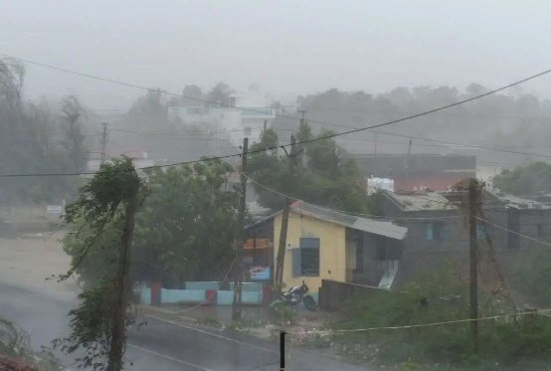
Biparjoy, a cyclone whose name means "disaster" in Bengali, is making its way across the Arabian Sea and is expected to make landfall as a "very severe cyclonic storm" on Thursday evening, government weather monitors said. Powerful winds, storm surges, and lashing rains were forecast to hammer a 325-kilometer (200-mile) stretch of coast between Mandvi in India's Gujarat state and Karachi in Pakistan.
India's Meteorological Department predicted the storm would hit near the Indian port of Jakhau late on Thursday, warning of "total destruction" of traditional mud and straw thatched homes. Wind speeds are predicted to reach 125-135 km/h, with gusts of up to 150 km/h, by the time it makes landfall.
Pakistan's climate change minister Sherry Rehman said on Wednesday 14 June that 62,000 people had been evacuated from the country's southeastern coast, with 75 relief camps set up at schools and colleges. She said fishermen had been warned to stay off the water and small aircraft were grounded, while flooding was possible in the megacity of Karachi, home to about 20 million people.
(16-6-23) Cyclone Biparjoy slammed into the Indian coast with powerful winds, sowing fear and prompting evacuations, but began weakening in the early hours of Friday 16 June as it moved north.
The "very severe cyclonic storm" crossed the coastline near Jakhau Port on 15 June Thursday evening, but started losing force several hours later and at 2:30 am (2230 GMT) on Friday was packing 100 kilometers (62 miles) per hour winds with gusts up to 110 km/hour, the Indian Meteorological Department (IMD) said in the latest bulletin.
"It would move northeastwards and weaken into a cyclonic storm by the early morning of the 16th (of) June," the bulletin read.
(17-6-23) Cyclone Biparjoy tore down power poles and uprooted trees Friday after pummelling the Indian coastline, but the storm was weaker than feared and there were two confirmed deaths.

Philippine ecumenical body for peace talks with ‘Reds’
(15-6-23) A Philippine ecumenical group has insisted on a peaceful strategy to resolve the violent insurgency in the country as authorities declined to resume talks with the communist party.
Gilbert Teodoro Jr., the newly appointed defence chief, said on June 13 President Ferdinand Marcos Jr. would not negotiate with “terrorists” and the Communist Party of the Philippines must stop attacking state forces if it wanted to engage in peace talks.
The Philippine Ecumenical Peace Platform (PEPP), an anti-violence group composed of Catholics, Protestants, and Muslims, in a statement on June 14 insisted that “as church leaders, we are consistent in our belief that an all-out-war policy will not resolve the decades-old armed conflict.”
It further said that violence “will be costlier in terms of the loss of lives and the budget for war material” and reminded that “an all-out violence policy” by previous administrations did not work and “brought only widespread violation of human rights.”

Bangladeshi Santals demand speedy probe into atrocities
(15-6-23) Some 1,000 tribal people, a majority of them Christians, staged a three-hour protest in a northern Bangladesh district to demand justice for the 2016 police atrocities in their village, as a local court was slated to hear their petition.
"We have gathered to show our resolve to get justice,” said Philemon Baske, president of Sahebganj-Bagdafarm Bhumi Uddhar Sangram, a platform formed by the victims of police excesses on 2,000 Santals and 500 Bengali families over a dispute involving their ancestral lands acquired for setting up a state-owned sugar mill in the northern Gaibandha district. “We will get it,” Baske asserted during the July 15 protest at Katamor in Gobindaganj, a subdistrict of Gaibandha.
Several Santal and Bengali leaders spoke on the occasion, accusing the government of protecting the masterminds behind the atrocities.
Most of the Santals, one of Bangladesh's oldest tribes, are Christian.
16-6-23
Pope discharged from hospital, returns to Vatican
(16-6-23) Pope Francis was discharged from Gemelli Hospital and returned to the Vatican on June 16, nine days after undergoing intestinal surgery.
The Vatican said that the Pope’s recovery has been smooth, with no complications. Dr. Sergio Alfieri, who performed the operation, said: “The Pope is well. He’s better than before.”
On his return trip to the Vatican, the Pope stopped at the basilica of St. Mary Major, to pray before the icon of the Virgin Mary—as he has done after each of his foreign trips, and as he did after his earlier operation to remove a portion of his intestine.
The Pope joked with reporters as he left the hospital, commenting: “I’m still alive.”
The Vatican has confirmed that Pope Francis will make his regular Sunday Angelus audience on June 18. However, he will not hold a mid-week audience next Wednesday, to avoid strain as his recovery continues.

Cardinal Ouellet denies new allegations of sexual assault; Pope Francis allegedly informed in 2014
(16-6-23) Cardinal Marc Ouellet, the recently retired Prefect of the Dicastery for Bishops, has denied new allegations of sexual assault.
The allegations emerged in the defamation case that Cardinal Ouellet initiated in December against Paméla Groleau, who worked for the prelate when he was Archbishop of Quebec. In an August 2022 lawsuit, Groleau had accused him of sexual assault of touching her inappropriately at different events between 2008 and 2010. Another woman in her letter addressed to Pope Francis alleged of a similar event in 2014.
“Ms. Groleau’s view of things is not in keeping with the person I am and amounts to new defamatory allegations,” Cardinal Ouellet said in response to the new allegations. “I firmly deny having made any inappropriate act whatsoever in relation to these women.”
Papal condolences following migrant shipwreck off Greek coast
(16-6-23) Cardinal Pietro Parolin, the Holy See’s Secretary of State, has sent a telegram of condolence in the Holy Father’s name to the apostolic nuncio in Greece following the Messenia migrant boat disaster, which claimed the lives of at least 78 people.
Milan archbishop delivers ‘punchy eulogy’ at Berlusconi’s funeral
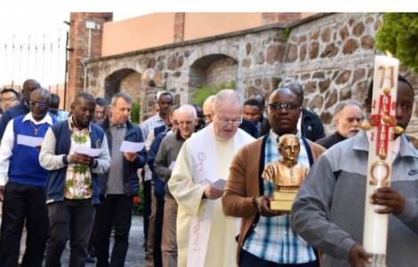
(16-6-23) Archbishop Mario Delpini of Milan celebrated the funeral Mass of Silvio Berlusconi (1936-2023), the media magnate who served three terms as Italian prime minister. Pope Francis had earlier offered his condolences to Berlusconi’s family.
Italy - The Consolata Missionaries have elected the X Superior General: the first of African origin
(16-6-23) Fr James Bhola Lengarin IMC is the new Superior General of the Consolata Missionaries. A missionary born in Kenya, he was elected on June 12 as the tenth Superior General in the history of the Consolata Missionary Institute, IMC, the first of African origin to hold the position.
The 14th General Chapter of the Consolata Missionaries has been underway in Rome since May 22 and will end on June 25 with the participation of the General Direction, Superiors and Delegates of the thirteen circumscriptions of Africa, Asia, America and Europe. The Superior General will hold office from 2023 to 2029. He will be assisted in the exercise of office by four Councilors. At the last General Chapter he was elected Vice Superior, a post he held from 2017 to 2023. In its 122-year history, the Institute of the Consolata Missionaries, founded in 1901 by Blessed Giuseppe Allamano, has grown into an international and multicultural congregation, with 906 missionaries from 30 countries working in 231 communities in 29 countries in Africa, America, Asia... and Europe.
Sudan - Governor of West Darfur State assassinated after asking for international protection
(16-6-23) The governor of West Darfur state and head of the Sudanese Alliance, Khamis Abdallah Abkar, was killed on Wednesday, 14 June, two months after the start of the armed conflict between the Sudanese army and the Rapid Support Forces (RSF) in Khartoum.
Fiji - “Laudato Sì”: Missionaries from St. Columban want to start environmental movement
(16-6-23) The Commission "Justice, Peace and Integrity of Creation" of the Missionary Society of St. Columban wants to work within a new movement for the implementation of the principles of the encyclical "Laudato Sì": it is a question of protecting and promoting the very life of the people on the Pacific islands, to ensure the survival of the islands themselves, threatened by phenomena such as global climate change and sea level rise. "It is a complex, comprehensive, global and also moral obligation for all of us to try, together with our governments, non-governmental organizations, civil society, scientists, theologians and communities, to promote the preservation of human life and the 'common home' at various levels in our societies, as Pope Francis says in Laudato Sì", say the missionaries, who are attending study days in Suva to discuss the actions to be taken and raise awareness in the local community.

Catholic nuns want justice for India's female wrestlers
(16-6-23) Indian police have filed charges against the former head of the Wrestling Federation of India following complaints of sexual harassment by female wrestlers, including international medal winners.
The police charges against Brij Bhushan Sharan Singh, an influential member of the pro-Hindu Bharatiya Janata Party (BJP) include criminal force against a woman with intent to outrage her modesty. Sexual harassment, making sexual remarks, and stalking are also among the major charges.
“It is true the police filed the charges after public pressure. No doubt, it is appreciated,” said Sister Cynthia Pais from Bengaluru, the capital of southern Karnataka state.
The nun, however, questioned the slow process.
“There is no free environment in the country for women to fight such cases," Sister Pais, a member of the Congregation of the Sisters of the Little Flower of Bethany, told UCA News on June 16.
Farmers, civil groups, and Catholic religious had come in large numbers to support the wrestlers and demanded action against Singh.
The police, however, have canceled the charges leveled against him by a minor wrestler through her father under the stringent Protection of Children against Sexual Offences (POCSO). The minor wrestler, according to the police, withdrew her complaint. “The police should re-investigate the complaint of the minor,” Sister Pais asserted. “It is not a simple case, she should get justice,” the nun added.
The wrestlers alleged they were harassed during tournaments in Indonesia, Kazakhstan, Bulgaria, Kyrgyzstan, and Mongolia.
After an appeal to the Supreme Court by the female wrestlers, the police registered two cases on April 28, including one under a special law meant to protect minor children from sexual exploitation. The police, however, did not make any progress in investigating the case.
“We should not be happy with the filing of charges,” said a nun who did not want to be named. “The general public and others who supported the wrestlers should continue their vigil until the accused is convicted," the nun based in southern Kerala state told UCA News.

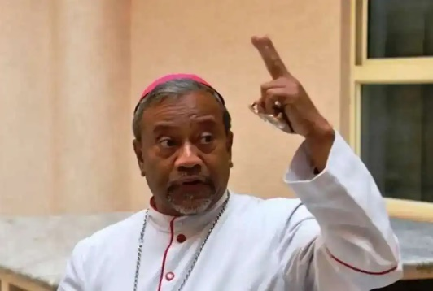
Bishop hails Indian state’s scrapping of anti-conversion law
(16-6-23) A Catholic archbishop has applauded the newly elected government in southern Karnataka state for its decision to repeal a controversial law that criminalized religious conversion.
“I express my profound gratitude and satisfaction towards the government of Karnataka for its decision to repeal the Karnataka Protection of Right to Freedom of Religion Act, 2022,” said Archbishop Peter Machado of Bangalore (now Bengaluru), the state’s capital.
The church leader’s reaction came hours after the state cabinet under Chief Minister Siddaramaiah, who goes by a single name, gave its nod on June 15 for abrogating the controversial law popularly known as an anti-conversion law, in keeping with the election promise.
The previous pro-Hindu Bharatiya Janata Party (BJP) government enacted the law in September 2022 ignoring objections from opposition parties, and minority communities including Christians and Muslims who make up 2 percent and 13 percent respectively of Karnataka’s 64 million people.
Leaders from the minority communities contended that the law would serve as a tool in the hands of hardline pro-Hindu groups to target them.
The BJP was ousted in the May state election and a secular government of the Congress party took its place.
Archbishop Machado who was at the forefront of the campaign to oppose the law said “the cabinet decision vindicated the stand of various stakeholders including Christians” and was “important for upholding fundamental rights” as enshrined in the Indian Constitution.
“It reaffirms the belief that the legislation was not only detrimental to an individual's freedom of religion but also stood in direct contradiction to the provisions enshrined in Article 25 of the Indian Constitution that guarantees freedom to practice, profess and propagate any religion for a diverse and pluralistic society,” the prelate said in an official release issued on June 15.
He said the anti-conversion laws in Karnataka and other Indian states have drastically increased attacks against Christians “as they encouraged the fringe elements to attack us without fear.” He added, “I hope the other states will also follow suit and abrogate such laws as well.”

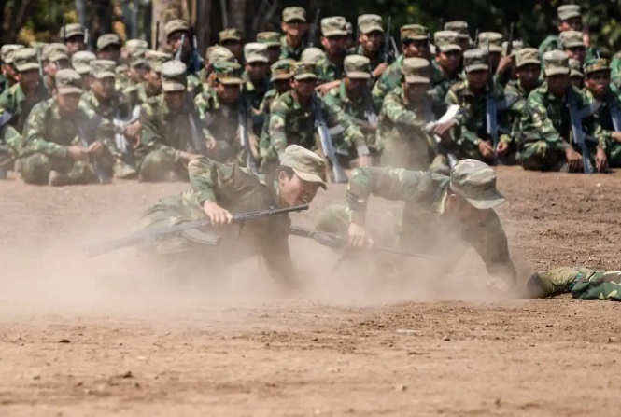
Heavy fighting in Myanmar 'kills many civilians'
(16-6-23) More than two dozen civilians have been reportedly killed since May 27 amid heavy fighting between junta forces and rebel groups in Myanmar, according to local rights and humanitarian groups.
At least 30 civilians were killed or reported missing from May 27 to June 12, in Mobye in Shan state, located between the capital Naypyitaw and an area controlled by a rebel group, according to the Karenni Human Rights group. “At least two civilians were injured at Loi Wa village, in Loikaw township, in shelling by the military from Loikaw to Mobye and nearby areas on June 14,” the group said on its Twitter account on June 15.
Heavy fighting was taking place in Shan state after the military stepped up an offensive on May 27, the group said. Thousands, including many Christians, flee shelling in Moybe in Shan state after junta steps up attacks on rebels.
17-6-23
Bangladesh - The Pope's Apostolic Letter "Desiderio Desideravi" is in Bengali, in a work by Cardinal D'Rozario
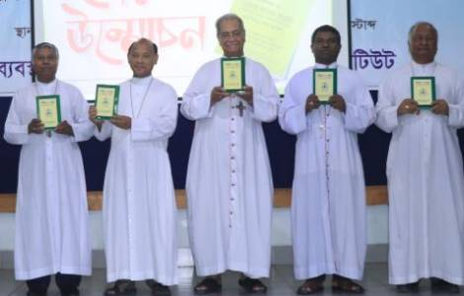
(17-6-23) Pope Francis' Apostolic Letter "Desire you wished" was translated into Bengali and was illustrated and commented for the benefit of the faithful in a book written by Cardinal Patrick D'Rozario, Archbishop Emeritus of Dhaka. The initiative was the result of a discussion between the Bangladeshi bishops: "We bishops thought that all the faithful in Bangladesh, priests, religious and laity, should know the message of the apostolic letter Desiderio Desidevi, to rediscover the liturgy as a place of privileged encounter with Christ. We thank Cardinal Patrick for his careful and competent translation work. The text will be very useful for the faithful in all dioceses and parishes", remarked Bishop Gervas Rozario of Rajshahi, speaking at the presentation of the text, organized recently by the Bishops' Conference in Dhaka. “This document is valuable to the Catholic Church in our country and the observations contained therein are very important to us. In the name of all the People of God, I thank Cardinal Patrick D'Rozario”, said Archbishop Bejoy N D'Cruze, current Archbishop of Dhaka, and president of the Catholic Bishops' Conference of Bangladesh.
18-6-23
Pope at Angelus: God is with you in your most difficult times
(18-6-23) Pope Francis opened his Sunday Angelus address by expressing his profound gratitude to all for their affection, care, friendship, and prayerful support during his time at Rome's Gemelli Hospital. The Pope returned to the Vatican on Friday after release from the hospital.
Taking his cue from the Gospel of Matthew (Mt 10:7), in which Jesus sends the Apostles forth to proclaim that the kingdom of heaven is at hand, he noted that the fact that “His lordship of love, has come near” and is in our midst is “the fundamental reality of life.”
“Indeed, if the God of heaven is close, we are not alone on earth, and even in difficulty we do not lose faith,” he said.
Explaining that God is a father who knows his children and loves them, the Pope assured the faithful that “even when you travel on steep and rugged paths, even when you fall and struggle to get up again and get back on track,” the Lord is close.
Inviting believers to stay with the image of a loving father who takes his child by the hand making the world, that appears “large and mysterious,” familiar and secure, the Pope invited them to go out and proclaim God’s vicinity.
“If we want to be good apostles, we must be like children,” the Holy Father said, allowing the Father to transform our hearts and give us that joy and that peace that we ourselves cannot attain.
The way to proclaim that God is near, the Pope continued, is not “by saying many words, but performing many deeds of love and hope in the name of the Lord.”
Pope Francis concluded inviting the faithful to ask themselves whether they believe and confide in God, whether they listen to the Word and partake of the Sacraments; whether they know how to instil courage in others and be close to those who suffer and are alone.
Pope Francis remembers victims of shipwreck off coast of Greece, Uganda students killed
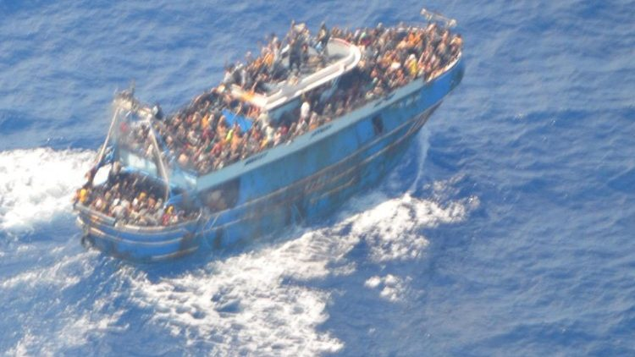
(18-6-23) At the conclusion of Sunday's Angelus, Pope Francis recalled that Tuesday 20 June marks the United Nations World Refugee Day. And on this theme he expressed his great sadness and sorrow when remembering the tragic shipwreck carrying an estimated 700 passengers that occurred last Wednesday 14 June, off the coast of Greece, even with it seems the sea was calm.
The search for the missing in international waters continues. At this time 78 people are confirmed dead and 104 have been rescued. Around 100 children are among the missing it what may be confirmed to be the biggest tragedy in the Mediterranean.
Encouraging everyone to "pray for peace," Pope Francis turned his thoughts to the young students who were victims of a "brutal attack" on a school in western Uganda. The Pope asked everyone to pray for peace wherever there is tension and war.
According to local authorities, the rebels of the Allied Democratic Forces (ADF) provoked the attack. Among the victims were 38 young students from the secondary school in Lhubiriha. The public school is located in the Ugandan district of Kasese, in the west of the country and two kilometres from the border with the Democratic Republic of Congo.
The Allied Democratic Forces (ADF) are accused of launching many attacks against civilians in recent years, particularly against communities in remote areas of eastern Congo. The militiamen are opposed to the government of Ugandan President Yoweri Museveni, in power since 1986.
----------------------------------------------------------------------------------------------------------------------------

