CATHOLIC WORLD LAST WEEK
(CWLW)
29 May-4 Jun 2023
29-5-23
Paolo Ruffini: Social Media have the power to build a better world
(29-5-23) Social media are a way for the Church to be among the people, and work toward the common good, not about compromising the truth to gain followers or 'likes,' says Dr Paolo Ruffini. The Prefect of the Vatican's Dicastery for Communication was speaking with Vatican News after presenting the Dicastery’s new theological and pastoral document reflection on social media, titled “Towards Full Presence. A Pastoral Reflection on Engagement with Social Media."
The Document's aim is to promote a common reflection on the involvement of Christians in social media, which have increasingly become part of people's lives. Inspired by the parable of the Good Samaritan, the document offers an opportunity to begin a shared reflection on how to promote a culture of being "loving neighbours" in the digital world as well.
The social media in which we should be present, he noted, should not "nourish hate speech, fake news, deepfakes," but "nourish the truth, the love and compassion." "We know that maybe a fake news [will] have more followers than the truth, but is this the way we will develop the better world? I don't think so," said Ruffini.
IN an interview Sister Nathalie Becquart discussed the proper approach to social platforms. ”It's very important that this document helps people to do their own discernment, especially with others as Christians in their own community, to find and to discern the way and ongoing discernment." She also acknowledged the risks inherent in social media and underlined the need to educate the people. Sr. Becquart highlighted that sensibility, awareness and good judgment are required.
Msgr. Lucio Ruiz, the Secretary of the Dicastery for Communication, offered a reflection on the work, and highlighted how we can learn from missionaries, who, before their tremendous work, learned 'the language' to communicate and contribute to the new evangelization. Msgr. Ruiz said
It (the social media) is the culture, nowadays, and where there is man, there, the Church needs to be present."
Sr. Veronica Donatello, S.F.A., head of the National Service for the Pastoral Care of Persons with Disabilities of the Italian Episcopal Conference (CEI) and a consultor of the Holy See Dicastery for Communication, highlighted during the press conference, how social media can be an important tool for disabled people. However, Sister Donatello warned that despite the great value of these technological resources, they will never be able to replace what is real, such as being present or offering an embrace.
‘Bullying destroys life,’ Pope tells Scholas Occurrentes
(29-5-23) Pope Francis addressed the conclusion of the first World Congress of Eco-Educational Cities, organized by Scholas Occurrentes.
Founded in Buenos Aires by the future Pope Francis and now a pontifical foundation, Scholas Occurrentes seeks “to promote a new education, and its mission is to create a culture of encounter bringing young people closer to a meaningful education,” according to its website.
Pope reflects on the Catholic imagination
(29-5-23) On May 27, Pope Francis received participants in a conference organized by La Civiltà Cattolica and by Georgetown University. The conference’s theme was “The Global Aesthetics of the Catholic Imagination.” The Pope told the assembled artists, “This, then, is the challenge facing the Catholic imagination in our time; it is a challenge entrusted to you: not to ‘explain’ the mystery of Christ, which is ultimately unfathomable, but to enable us to touch him, to feel his closeness, to let us see him as alive and to open our eyes to the beauty of his promises.”
Pope again condemns proselytism
(29-5-23) Pope Francis renewed his denunciation of “proselytism,” and repeated a story about his rebuke to a woman for converting children, during a May 29 audience with members of the Barnabite order.
“Be careful to distinguish apostolic action from proselytism; we do not proselytize,” the Pope said.
The Pope recounted a story that he has told in the past, about a woman who introduced him to two young people who had entered the Catholic faith. He said: “I was angry, you know, and I said, ‘You haven’t converted anyone, you lack respect for these people: you have not accompanied them, you have proselytized, and this is not evangelizing.’”
Pope encourages African youth to conquer continent’s problems
(29-5-23) In a private audience with young people from Africa, who were in Rome for the celebration of Africa Day, Pope Francis said: “Never give up on your dreams, never completely bury a calling, and never accept defeat.”
The Pontiff acknowledged that young people in Africa face serious difficulties, but encouraged them to have confidence and persevere to overcome those problems. He said:
Your beloved African continent is facing enormous challenges such as terrorism, bad governance, corruption, massive youth unemployment, migration, conflicts between communities and the climate and food crisis, among others. In this context, you may feel helpless and discouraged, and think that your future is bleak and without prospects. Yet you are young and richly talented, you have lofty ambitions and great dreams: pursue them!
Enormous Chartres pilgrimage captures French media attention
(29-5-23) An annual pilgrimage of traditionalist Catholics to Chartres has captured the attention of the media in France, with a record-breaking number of participants joining in the three-day procession.
Organizers of the event cut off registration for the weekend pilgrimage more than a week before it took place, as the number of registrations exceeded the maximum (16,000) that they could accommodate. But considerably more “unofficial” participants joined in the 60-mile hike from Paris to Chartres. Bishop Philippe Maurice Christory of Chartres joined in the march as the pilgrimage crossed into his diocese.
The Chartres pilgrimage has taken place each year since 1983, attracting Catholics who are drawn to the traditional Latin liturgy.
Italian president awarded Paul VI prize
(29-5-23) Pope Francis has awarded the Paul VI prize, given to individuals who “have contributed to the growth of the religious meaning in the world,” to Italy’s President Sergio Mattarella.
In presenting the award— on May 29, the feast of St. Paul VI— the Pope spoke about the message of Vatican II, encouraging lay activity to transform the secular world with the message of the Gospel.
Nigeria - Precarious security situation: Another Catholic priest kidnapped in Imo State
(29-5-23) A week after the kidnapping of Father Kingsley Maduka and his subsequent release, the kidnapping of another Catholic priest in Imo State (south-eastern Nigeria) is causing concern in the local community.
The details of the kidnapping also indicate that the kidnappers were specifically targeting the priest. Father R. Mathias Opara was kidnapped by unidentified gunmen on the evening of May 26 on the Ejemekwuru-Ogbaku road, which connects Oguta and Mbaitoli local governorates. The priest was on his way back to Owerri from the funeral of another priest's father in Izombo, Oguta Local Government Area, Imo State.
According to the spokesman for the Catholic Archdiocese of Owerri, the attackers came out of the bushes to attack Father Opara and the other passengers traveling with them. But while the other three people were being released, the kidnappers fled into the forest, taking Father Opara with them.
The exact motivation behind what appears to be a targetted kidnapping is not clear.
Turkey - Erdogan remains in power. Bishop Bizzeti: the inadequacy of certain Western analyzes emerges
(29-5-23) The final results of the elections in Turkey, with the victory of the incumbent President Recep Tayyip Erdogan, also highlight "the inadequacy of Western media tools in presenting the Turkish situation". This was underlined by Bishop Paolo Bizzeti SJ, Vicar Apostolic of Anatolia, who pointed out that "the Catholic Church has never had any problems with Erdogan's government".
President Erdogan received 52.16% of the votes in the presidential runoff held on Sunday, May 28. Bishop Bizzeti explains the feelings that the election result could evoke in the Christian communities in Turkey: "To be honest, the Catholic Church has never had any problems with Erdogan's government. There are questions that have always been unresolved, such as the legal personality of the Catholic Church. But these are problems arising from the Treaty of Lausanne, and certainly not from the government of the AKP, Erdogan's party." "Besides," adds the bishop, "there is a certain Kemalist secularism which relegates religion to the private sphere, is not very desirable for us. On this point, too, we must break away from certain trivializations. In Europe, the total secularism of the state is considered a value, but there are controversial situations and questionable aspects. A government that takes into account the religious sentiments of the people is in any case desirable for us. We cannot accept a religion simply relegated to consciences."
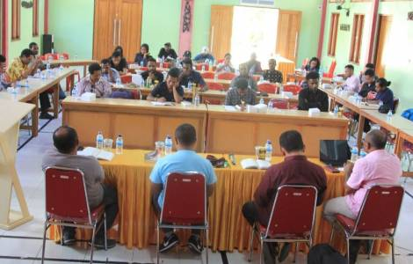
Indonesia - Tense situation in Papua: Catholics are trying to resolve the conflict
(29-5-23) "The conflict in the Indonesian Papua region is destined to increase in intensity, due to the growing deployment of members of the Indonesian security forces, after the case of the kidnapping of New Zealand pilot Philip Mark Mahrtens, seized by the Army of Papuan Liberation (TPN-PB) last February. The issues to be addressed are varied and complex. The sense of justice of the Papuan people has been severely violated. For example, people suspected of human rights abuses in Paniai, a small town in Puncak Jaya district, in 2014 were released without charge by the local court. The right to freedom of expression of student groups was suppressed by local authorities. Several officials were arrested on corruption charges, including the governor of Papua, Lukas Enembe, and the regent of Central Memberamo, Ricky Ham Pagawak. In addition, due to the violence, school classes in the Pegunungan Bintang regency are being disrupted, while the central government-sponsored program of transmigration to the new autonomous regions will result in increasing displacement of the indigenous Papuans," said Father Alexandro F. Rangga OFM, Coordinator of the "General Office for Justice, Peace and Integrity of Creation" of the Friars Minor in West Papua, a region of Indonesia tormented by violence and instability.
In the local Catholic faith community, many actors are trying to create an atmosphere of reconciliation. The Franciscan Commission for "Justice, Peace and Integrity of Creation" continues to work with other NGOs and published a report entitled "Terpasung di Rumah Sendiri" ("Trapped in our home"), which documents episodes and chronicles of citizens who have suffered injustice, violence and oppression at the hands of Indonesian authorities in recent years. The Franciscan network seeks to monitor human rights abuses, drawing on international recommendations from the UN. The NGO "Franciscans International" will participate in the 53rd session of the UN Human Rights Council in June 2023 and will present a report on the situation on the ground in Papua.

Sri Lanka arrests stand-up comedian for insulting Buddhism
(29-5-23) Sri Lankan police have arrested a stand-up comedian reportedly while she was attempting to flee the country after a public backlash against her performance insulting Buddha and Buddhists.
Police accused Jayani Natasha Edirisuriya of disrespecting Buddha, ridiculing Buddhist girls as "virgins" and saying "protecting their virginity is the biggest goal” for Buddhist-run schools.

Indian bishops say Manipur riots targeted tribal Christians
(29-5-23) The sectarian violence in Manipur state in north-eastern India was "well-orchestrated" and "targeted the Kuki tribe," 90 percent of whom are Christians belonging to different denominations, alleged a Catholic bishops’ body from southern Kerala state.
“It is true that the normal conflict between the majority local Hindu community representing Meiteis and indigenous people, mostly Christians, was communalized and used to destroy tribal Christians,” said Father Michael Pulickal, secretary of the Kerala Catholic Bishops' Commission for Social Harmony and Vigilance, which carried out an inquiry into the Manipur riots.
Father Pulickal, backed by inputs from reliable sources, told UCA News on May 29, three days after releasing a report of the commission, that “the pro-Hindu Bharatiya Janata Party (BJP) changes its colors for power” and the violence “has exposed the double standards” of the party. The BJP rules India and Manipur state.

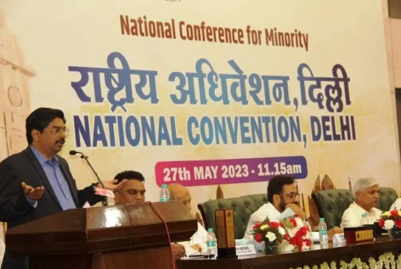
Minority body demands India uphold constitution guarantees
(29-5-23) A national body of Indian minorities has demanded the federal government guarantee them the constitutionally protected right to practise and profess their religion and protect them from hate speech, intimidation, attacks and killings.
Some 100 members of the National Conference for Minority and invitees including politicians, activists, writers and students made the demands at a gathering on May 27 at the Constitution Club in the national capital New Delhi to discuss the situation of religious minorities across the country
The one-day convention also demanded the setting up of an equal opportunities commission to ensure a proportional share in the nation’s finances and resources, besides fair representation in electoral politics of the country.
P. Wilson, a Christian member of the Rajya Sabha, or Upper House of the Indian parliament, said Christians had contributed immensely to nation building, especially in the fields of education and health, but instead of acknowledging it they were being falsely blamed for religious conversions.
Wilson, who is a lawyer from the southern Tamil Nadu state, said: “Minorities are also citizens of this country and India belongs to them equally.”
Syed Imtiyaz Jaleel, a Muslim member of the Lok Sabha, or Lower House of parliament, recalled being educated in a Christian missionary school “but never seeing any priest or nun asking someone to follow Christianity or forcing to attend church or any prayer service.”

HK Christian group honours schools for student welfare
(29-5-23) A Christian charity in Hong Kong has honoured schools including those run by Catholic and Protestant churches for promoting the holistic welfare of students including ensuring mental well-being during the Covid-19 pandemic.
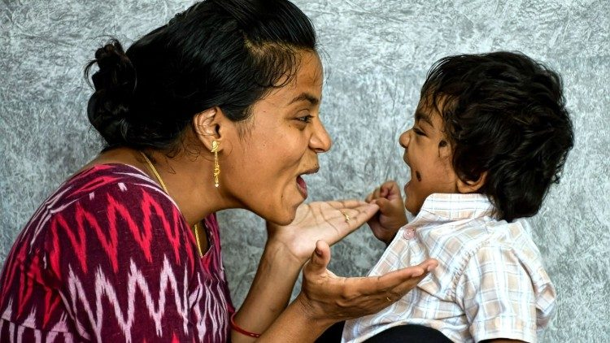
Hong Kong Christian Service (HKCS) named 11 schools as recipients of its merit award for 2022, the group said in a press statement. Representatives from more than 100 schools attended the event on May 27. The award winners were among 400 schools that are part of HKCS’s Caring School Award Scheme for the ‘Holistic Care for the Well being’ of students that began in 2005. The schools have continued to promote the well-being of students despite the pandemic posing many challenges over the past three years, HKCS said.
30-5-23
Vatican launches ‘Family Global Compact’
(30-5-23) On May 30 the Vatican launched a new initiative to promote strong family life, the Family Global Compact.
An initiative of the Dicastery for Laity, Family, and Life, the Family Global Compact was launched with a statement of support from Pope Francis, who said that the health of the family is “decisive for the future of the world and that of the Church.” The goal of the initiative is “to enable the pastoral care of families in the particular Churches to benefit from the research and the educational and training programs in Catholic universities.” Toward that end the project will link with Catholic research centers, encourage their work on family life, and make their latest findings available to pastors.
Pope Francis said: “Catholic universities have the task of developing in-depth theological, philosophical, legal, sociological and economic analyses of marriage and the family, in order to uphold their importance within contemporary systems of thought and action.”
Jesus and Mary are close to you, Pope tells young cancer patients
(30-5-23) On May 29, Pope Francis received pediatric cancer patients from the Wroclaw Oncological Clinic in Poland.
“You are never alone!” the Pope said to the children, gathered in a room adjacent to the Paul VI Audience Hall. “Jesus is always by our side to give us hope ... If someone finds himself alone and feels abandoned, let us not forget that Our Lady is always close to us, especially when the burden of illness, with all its problems, makes itself felt.”
Nicaragua accuses Church of money laundering, freezes accounts
(30-5-23) As the persecution of the Church in Nicaragua intensifies, the regime of Daniel Ortega has frozen the bank accounts of parishes and has accused dioceses throughout the nation of being “part of a money laundering network.”
‘We don’t have an agenda’ for Synod on synodality, Cardinal Grech says in new interview
(30-5-23) Cardinal Mario Grech, Secretary General of the Synod of Bishops, told EWTN that issues like same-sex marriage, abortion, and women’s ordination are being put “on the back burner, as they are not issues that should be tackled by this particular synodal assembly” on synodality.
“If we enter into those issues at this particular moment, we will miss a golden opportunity, a moment of grace, a reflection on how we can really help the Church to become more synodal and create those spaces where all the members of the people of God, under the leadership and the guidance of their pastors, can really contribute to evangelization,” he said.
Cardinal Grech also distanced the Synod on synodality from Germany’s Synodal Way. “It is not a synod in Germany, he said. “It’s a synodal journey. A synodal way, they call it. Canonically it is neither a diocesan nor a national synod, as far as I know. They are two different ecclesial experiences.”
3 priests arrested in Belarus
(30-5-23) “The Belarusian authorities are cracking down on any public criticism of [Alexander Lukashenko’s] regime and his support for the Russian war against Ukraine,” the Polish Press Agency reported.
Belarus, an Eastern European nation of 9.4 million, is 80% Christian (65% Orthodox, 12% Catholic).
Syro-Malabar synod announces emergency meeting to end liturgical dispute (The Hindu)
(30-5-23) Following a Vatican meeting, Cardinal George Alencherry, head of the Syro-Malabar Catholic Church, has convoked an emergency meeting of the church’s bishops to address the liturgical dispute that has divided the church.
Cardinal George Alencherry, Major Archbishop and head of the Syro-Malabar Church, has convened an emergency meeting of the synod of bishops of the Church at its headquarters, St. Thomas Mount, Kakkanad, between June 12 and 16.
The official order on the synod meeting has been handed over to the synod members by the Major Archbishop, said an official communication from the Syro-Malabar Church here.
The synod is being convened on instructions from the Holy See after permanent synod members visited Rome early this month, said the communication issued by Fr. Antony Vadakkekara, Public Relations Officer and media commission secretary. Central to the synod meeting will be a resolution of the problems confronting the Ernakulam-Angamaly archdiocese in implementing the unified Mass, the communication added.
The Cardinal had led the permanent synod members to Rome early this month to hold discussions with Cardinal Pietro Parolin, secretary of State in the Vatican and Archbishop Claudio Gugerotti, prefect of the Dicastery for the Eastern Churches. It is learnt that the issues confronting the Church, including the division over the Mass celebration, figured prominently in the discussions.
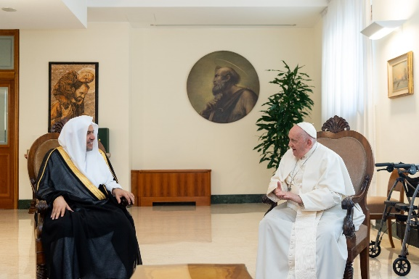
Head of Muslim World League meets Pontiff
(30-5-23) A Muslim leader with a reputation for promoting tolerance and interfaith dialogue met Pope Francis on May 27.
“Delighted with the sincere, brotherly and deep dialogue with Pope Francis at his residence,” tweeted Mohammed Al-Issa, secretary-general of the Mecca-based Muslim World League. “We discussed our shared values and building bridges between civilizations based on effective and sustainable initiatives. I appreciate Pope Francis’s kind hospitality and noble sentiments.”
Curiously, the Holy See Press Office did not include Al-Issa’s audience with Pope Francis in its list of the day’s papal audiences.
Archbishop Paglia discusses relevance of Humanae Vitae today
(30-5-23) In summer 2022, the Vatican publishing house published Theological Ethics for Life, a book that presents the proceedings of a conference organized by the Pontifical Academy for Life.
The work questions the Church’s teaching on contraception, and Archbishop Vincenzo Paglia, the Academy’s president, said that the work was intended to “introduce a paradigm shift.”
In a recent interview with Vatican News, Archbishop Paglia said that “I am in agreement with every provision of Humanae Vitae“ but that “we have to continue interrogating” the encyclical “for a deeper understanding of the connection that ties sexuality, married love and generation together, a connection made clearer by a personalist approach.”
“That’s why I believe continued reflection on the subject is very important, as are wide-ranging discussions,” he added.
Cardinal Becciu blasts vendettas, ‘plots against me’ in Vatican financial trial
(30-5-23) Cardinal Angelo Becciu, who oversaw the internal affairs of the Roman Curia as Substitute (Sostituto) of the Secretariat of State from 2011 to 2018, criticized Judge Giuseppe Pignatone after he ruled that the full text of interrogation transcripts and WhatsApp chats sought by Becciu’s attorneys should not be given to them.
Chad - The Episcopal Conference: "Enough of the blood and tears of Chadians"
(30-5-23) "The blood and tears of Chadians have shed enough and must stop" warn the Bishops of Chad in a memorandum addressed to the President of the Transition, Acting Head of State, Mahamat Idriss Déby.
The Episcopal Conference of Chad (CET) is asking the government to address the problems afflicting the population, such as the spread of insecurity, the shortage of basic necessities and the composition of the national Commission in charge of organizing the constitutional referendum (Conerec).
According to the Bishops, it is hard to believe that the killings and shortages of basic necessities in Chad are contingent and accidental. "The Government must act impartially and in the name of the law, if it does not want to be accused of being its author and of using terror as a means to govern, maintain or preserve power," the document states, referring to the violent repression, on October 20, 2022, of the demonstrations called to protest against the stay in power for another two years of the President of Transition Mahamat Déby, whereas he had promised to hand over power to the people after 18 months.
Sudan - Ceasefire extended for another five days: Numerous violations across the country
(30-5-23) The ceasefire between the Sudanese Armed Forces (SAF) and the Rapid Support Forces (RSF), which came into force on May 22nd and was scheduled to last for seven days, has been extended for another five days. According to local sources, an agreement was reached between the Sudanese parties in a meeting in Jeddah mediated by Saudis and the United States.
However, fighting continues both in Khartoum and in other provinces, particularly in Darfur and Kordofan.
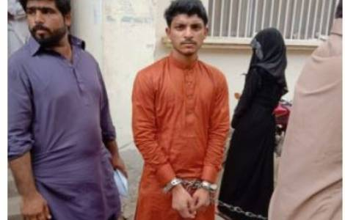
Pakistan - Young Christian sentenced to death for alleged blasphemy through WhatsApp
(30-5-23) Nouman Asghar, a 24-year-old Christian from the city of Bahawalpur, in Punjab, was sentenced to death for blasphemy on May 30, by a court of first instance in Bahawalpur. The young man had been arrested in 2019 for violating article 295-c of the Penal Code, which punishes contempt for the Prophet Mohammed, due to an alleged blasphemy through WhatsApp. Messages containing blasphemous drawings of the Prophet Muhammad were found on the mobile phone of the young man and his friend Sunny Mushtaq -who was also arrested- in the WhatsApp chat. The trial against the young man concluded last January, but it took five months for the district judge of the Bahawalpur Magistrate Court to deliver the verdict, which was made public today, May 30.
According to lawyer Aneeqa Maria Anthony, from the NGO "The Voice", which deals with the legal defense of Asghar and Mushtaq, "the magistrate ignored all the procedures and dismissed all the evidence in favour of the accused. He only wanted to complete his 'sacred duty' to punish an alleged blasphemer.”

Families demand probe into Bangladesh disappearances
(30-5-23) Families of victims and rights activists have reiterated their demand for an impartial probe to ensure justice and punishment for perpetrators of hundreds of alleged enforced disappearances in Bangladesh. They made the call while forming a human chain in front of the National Press Club in the capital Dhaka on May 27.
The event, organized by Mayer Daak (Mother's Calling), a platform for the families of the nearly 500 victims of enforced disappearances, marked the International Week of the Disappeared, observed in the last week of May. In the past decade, at least 200 people have disappeared, mostly after they were picked up by state agencies.

Activists, lawmakers decry Indonesia’s democracy decline
(30-5-23) Human rights groups and a church leader have lamented the gradual decline in freedoms and civil liberties in Indonesia as the Southeast Asian nation gears up to mark the 25th anniversary of the fall of military dictator Suharto and the return to democracy.
In a statement on May 30, members of ASEAN Parliamentarians for Human Rights (APHR) expressed concerns, especially with the increased monitoring of social media content, as well as digital attacks against human rights defenders and media organizations.
“Indonesia has taken great strides in democratic reform following the fall of the authoritarian New Order regime 25 years ago, but we are concerned that if current trends of restrictions on freedom of speech and expression online continue unchecked, this important progress will be lost,” said Yuneswaran Ramaraj, APHR member and Malaysian lawmaker.
Amnesty International’s report has cited the sedition charge against four Catholics earlier this month after they planned to hold a protest at the ASEAN Summit in Labuan Bajo, Flores, for not paying compensations to victims evicted for the construction of a road to one of the summit avenues.
Augustinian Father Bernard Baru, a human rights activist based in Papua said, "In the easternmost region, apart from restraining civil liberties, patterns of militaristic approaches to civilians have not changed so far, while cases of violence to extrajudicial killings have not been resolved."
Philippine bishops admit to Marian apparition 'failure'
(30-5-23) The head of the Catholic bishops’ forum in the Philippines has admitted the bishops’ failure in addressing contradictory views about an alleged Marian apparition, which recently led to the arrest of a priest.
Bishop Pablo David of Kalookan, president of the national bishops’ conference told UCA News that bishops should have facilitated dialogue to clarify confusion continuing about the alleged Marian apparition in Lipa Batangas, south of the capital Manila. “We humbly beg forgiveness for this shortcoming,” David said in a May 29 note to UCA News.
A former Carmelite postulant named Teresita Castillo claimed Virgin Mary appeared to her inside her convent room in Lipa in 1948. People began to venerate Our Lady of Mediatrix of All Graces in Lipa, but after an initial investigation, in 1951 the Vatican officially declared it “non-supernatural.”

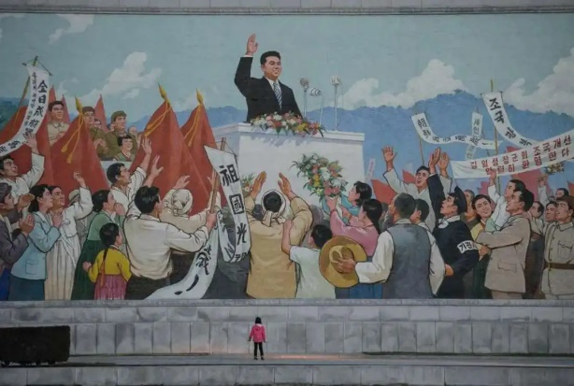
5 N. Korean Christians held for ‘illegal’ prayer gathering
(30-5-23) Five Christians remain in police detention following their arrest in communist North Korea for allegedly conducting an ‘illegal’ underground prayer gathering at the end of April, says a report.
Those arrested are members of the same family whose prayer meeting at their home was raided following a tipoff from an unknown informant, Radio Free Asia (RFA) reported on May 28.
The weekly prayer at the family’s farmhouse in Tongam, a village near the city of Sunchon in South Pyongan province, was stopped by police who took them away.
An unnamed resident told RFA that those arrested did not violate any law as they were not engaged in any public display or propagation of their faith during the gathering on April 30.

Indian bishop named in 'conversion' complaint, seeks anticipatory bail
(30-5-23) A Catholic bishop has been named in a complaint of alleged conversion against a Church-run orphanage, the latest in a series of actions meant to harass Christians in a central Indian state.
Bishop Gerald Almeida of Jabalpur has been named in a May 30 complaint registered by Priyank Kanoongo, chairman of the National Commission for Protection of Child Rights (NCPCR). Kanoongo's complaint accused Asha Kiran (ray of hope) Children’s Care Institute of attempting to convert Hindu children to Christianity. Kanoongo reportedly named the bishop in the complaint as the orphanage is managed by the Jabalpur diocese in Madhya Pradesh state's Katni district.
A team from NCPCR earlier conducted an inspection at the orphanage, which currently takes care of 47 missing or abandoned children rescued from railway stations in the region. “It is totally a baseless and false allegation,” Sister Stella, who works at the orphanage told UCA News on May 30.
The nun, a member of the Congregation of the Mother of Carmel (CMC), said Kanoongo’s action “seemed to be part of a well-orchestrated plan to target us.”
The bishop and Sister Liji Joseph, in charge of Asha Kiran filed anticipatory bail applications before the district court on May 30 in Katni district in Madhya Pradesh against their possible arrest.
(1-6-23) Father Thankachan Jose, a diocesan priest helping out with the case, told UCA News on June 1, “The orphanage has been engaged in building the lives of the abandoned or orphaned children on railway platforms since 2005.” He challenged Kanoongo to prove the allegation with “one credible case” rather than “misusing his official position. Such false cases will harm “poor children who get a place to stay, food, clothes and facilities to study,” the priest said.
The hearing of the case against the bishop and the nun, slated for last week, was postponed after the investigation officer failed to submit the records of the case.
Christian-run schools, hostels and orphanages in Madhya Pradesh have been facing investigations from officials of federal and state child rights protection panels for several months.
Sri Lankan monks seek alms to celebrate Poson Poya
(30-5-23) Buddhist monks have turned down the Sri Lankan government's offer for financial support and instead are seeking public donations to fund an annual festival Poson Poya celebrating the arrival of Buddhism centuries ago in the island nation in the Indian Ocean.
31-5-23
222 churches, 115 villages burned down in Indian state, tribal forum says
(Editor’s note: The eastern Indian state of Manipur is 41% Hindu, 41% Christian, 8% Muslim, and 8% Sanamahi.
Violence has erupted there between the predominantly Hindu Meitei people and the predominantly Christian Kuki )
(The Statesman, 30-5-23) Ethnic killings in Manipur are rising by the day. Tribals are reeling under severe shortages of regular medicine, daily supplies, and other essentials. Indigenous Tribal Leaders’ Forum (ITLF) claims that no one from the government has attended to their problems.
Speaking to The Statesman, Ginza Vualzong, of ITLF said, “The tribals are living under constant stress, scarcity, and lack of security. While there is non-stop violence going on in the region, the residents are facing a tough situation due to an acute shortage of regular supplies. The villages located within 100 kilometers of Imphal are witnessing the crisis.”
The visit of the Union Minister of Home Affairs Amit Shah to Manipur amid serious concerns over deteriorating law and order has raised hopes of different communities that have been at the receiving end following violence.
Further Ginza claimed that the Manipur state government along with the Manipur state forces have been carrying out ethnic cleansing continuously since 3rd May 2023 against the tribal people- who are mostly Christian, ed.- in different tribal villages wherein tribal villages were burnt down to ashes and many innocent tribals were murdered.
The ITLF believes that the valley underground cadres disguised in Manipur police uniforms were the perpetrators leading the endless horrific crime against the tribals.
According to ITLF, 68 tribal people have been confirmed dead and 50 or more are still unaccounted for. The number of churches burnt is 222, and the number of Administration Buildings/Quarters is 73 (seventy-three). Also, the number of villages burnt is 115 and the number of houses burnt is more than 4000. The number of tribal people injured is alarming. While the Support groups are in their designated camps, the poor tribal villagers defending their villages with just a handful of single barrels guns and a few licensed guns were collected from them by the Army leaving them helpless or leaving them to die at the hands of the State-led machinery.
Each one is dissatisfied, the local feedback ITLF claims. And with the ongoing ethnic killings and cleansing, the security forces at present have even started combing operations in tribal villages after allowing the loot of arms.
Ginza further added that the injuries suffered by the village volunteers indicate the use of these sophisticated weapons which were looted. “We strongly condemn the Manipur State Government forces’ actions and we appeal to the Central Government and the Central forces to deploy more forces in our villages to protect our innocent tribal villagers whose lives are in danger. We also demand the immediate imposition of President’s Rule in Manipur and the sacking of the N. Biren Singh led Government.”

Pope, at general audience, pays tribute to Venerable Matteo Ricci
(31-5-23) Continuing his series of Wednesday catecheses on the theme of “the passion for evangelization: the apostolic zeal of the believer,” Pope Francis devoted his May 31 general audience to Ven. Matteo Ricci, SJ (1552-1610). Here below is the summary of his talk.
In our continuing catechesis on apostolic zeal, we now turn to Matteo Ricci, one of the early Jesuit missionaries to the Far East, who fulfilled the dream of Saint Francis Xavier and entered China. Father Ricci patiently mastered the difficult Chinese language and immersed himself in the country’s culture. Thanks to his writings in Chinese and his knowledge of mathematics and astronomy, Matteo Ricci became known and respected as a sage and scholar. His vast learning and his ability to engage in sincere and respectful dialogue were employed in the service of the Gospel, which he made known not only in his writings but by his example of religious life, prayer and virtue, which attracted many of his Chinese disciples and friends to embrace the Catholic faith. Matteo Ricci was the first foreigner permitted by the Emperor to be buried on Chinese soil. In our day, Father Matteo Ricci can serve as an outstanding model for the inculturation of the Gospel. He also remains an inspiration for relations between the Church and China, and for dialogue between the cultures of East and West in the service of peace and fraternity among peoples.
Ireland: bigger, older, less Catholic
(31-5-23) According to Ireland’s 2022 census, the nation’s population has surpassed 5 million for the first time in 171 years, in large part because of immigration.
Only 69% of Irish say they are Catholic—down from 92% in 1991, 84% in 2011, and 78% in 2016.
Suspended priest elected governor of Nigerian state
(31-5-23) Father Hyacinth Alia, suspended in 2022, has been elected governor of Nigeria’s Benue State. Citing Canon 285, which bars clerics from political office, Father Alia’s bishop suspended the priest in 2022, when he declared his candidacy.
Macron meets Maronite Patriarch, calls on Lebanon to end ‘political impasse’
(31-5-23) Born in 1940, Cardinal Bechara Boutros al-Rahi has led the Maronite Church since 2011. Based in Bkerké, Lebanon, the church is among the Eastern Catholic churches in full communion with the Holy See.
In Lebanon, the president is traditionally a Christian, while the prime minister is a Muslim; the nation has lacked a president since October. French President Emmanuel Macron spoke of the need for Christians “to remain at the centre of the sectarian and institutional balance of the Lebanese state.”
Vatican foreign minister: Solidarity is a privileged path to peace
(31-5-23) Archbishop Paul Richard Gallagher, the Holy See’s Secretary for Relations with States and International Organizations, addressed GLOBSEC, a think tank “committed to enhancing security, prosperity and sustainability in Europe and throughout the world.”
Dicastery for Clergy signs agreement on protection of minors
(31-5-23) The Pontifical Commission for the Protection of Minors and the Dicastery for the Clergy have signed a memorandum of understanding on the protection of minors.
The key points of the agreement include the development of “spaces for listening to and welcoming survivors, collaboration for safeguarding in the particular churches [i.e., dioceses and eparchies], initial and ongoing training of priests on the ministry of safeguarding, as well as provisions for the exchange of information in order to compile an annual report that will be delivered to the Pope.”
Catholics lead protests against mining, oil drilling in Ecuadorian Amazon
(31-5-23) “Large-scale mining endeavors are something new,” said Bishop José Adalberto Jiménez Mendoza, OFM Cap, the vicar apostolic of Aguarico. “During the COVID-19 pandemic, illegal miners opened roads in the forest and brought heavy machines. We counted at least 200 backhoes.”
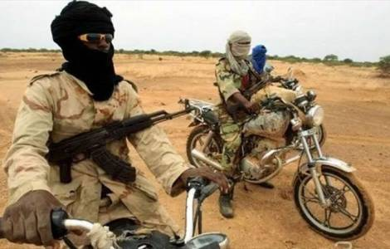
Burkina Faso - "Peace is a gift from God, but it is also the fruit of human effort", recalls Cardinal Ouédraogo, in the country devastated by violence
(31-5-23) At least 40 people died last weekend in jihadist attacks in Burkina Faso. This was announced by the local authorities, according to which 20 members of the voluntary militias supporting the army (VDP Volontaires pour la Défense de la Patrie), were killed on Saturday, May 27 in Bourasso, in the province of Kossi, near the border with Mali, and another 20 people lost their lives in the same region on Sunday, May 28.
The Bishops of the Regional Episcopal Conference of West Africa (CEREAO/ RECOWA) for their part called for peace and prayed for the conversion of the terrorists. "May God touch their hearts" they implored during their meeting held on May 20 in Ouagadougou. "This prayer is not limited to Burkina Faso. It applies to Nigeria, Mali, Niger and all other African countries hidden from the attention of the media, but suffering the violence of evil men." The Archbishop of Ouagadougou, Cardinal Philippe Ouédraogo, stressed that "peace is a gift from God; peace is also the fruit of human effort", and urged the people of God in Burkina Faso to "unite their voices to ask God for the grace of peace".
Indonesia - The "Marian month" ends with pilgrimages and visits to shrines
(31-5-23) More than 15,000 pilgrims have visited the cave dedicated to Mary, Our Lady of Perpetual Help, in Mbay, in the Archdiocese of Ende, on the island of Flores, considered "the Catholic heart of Indonesia", during the last days of May alone. The influx of faithful, from neighbouring parishes and even from outside the diocese, testifies to the renewal of pilgrimages and the movement that Marian devotion induces in Indonesian Catholic communities, especially during the months of May and October, traditionally dedicated to the Virgin.
An intense visit by the faithful has also been recorded at the Marian shrine of Graha Maria Annai Velangkanni, in the Indonesian city of Medan, North Sumatra, where the baptized come "to seek peace, comfort and healing from Mary, our Mother" , explained Jesuit Father James Barathaputra.
This was also the case in the diocese of Semarang, at the Marian sanctuary of Sendangsono, with the Grotto of the Blessed Virgin Mary of Lourdes, the oldest in Indonesia; in Poh Sarang, a small isolated village on the slopes of Mount Klothok, in the Kediri region of West Java; as well as in the Diocese of Bogor, at the Marian Shrine of the Immaculate Conception at Canadian Hill, in the Banten region.
Nicaragua - Nuns who ran an educational center expelled. "the Church is in the hands of the Holy Spirit"
(31-5-23) The sisters of the Hijas de Santa Luisa de Marillac Congregation had recently celebrated the 30th anniversary of the founding of the Santa Luisa de Marillac Technical Institute, in Yalí, Jinotega in Nicaragua, who were expelled from the educational centre now occupied by the police forces.
The sisters were in charge of the administration of the San Sebastián de Yalí Center. Foreign nuns have been deprived of their residences and have an expulsion order, while the Nicaraguan nuns have been confined to their respective convents.
During the celebration of the Feast of Pentecost on May 28, the Archbishop Leopoldo Brenes of Managua, stated that "the Church is in the hands of the Holy Spirit".

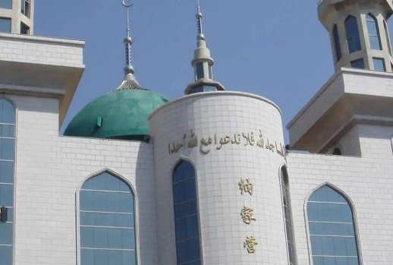
Chinese Muslims clash with police to defend mosque
(31-5-23) Thousands of Muslims from the ethnic Hui community in southwest China clashed with police and surrounded a mosque to stop the authorities from removing its dome and four minarets as part of a state campaign known as ‘sinicization of religion’ in the communist country, reports say.
An altercation over the partial demolition of the mosque between Muslim residents and police in Najiaying village, Yunnan province led to clashes last weekend, prompting the authorities to deploy hundreds of police and make arrests.
The Najiaying mosque was reportedly constructed in the 13th century and is among the last two government-approved Arabic-style mosques in the country, according to a report on the China Project site.

Eviction order for dam project irks Tibetans in China
(31-5-23) Tibetan villagers living in western China have criticized the authorities for an eviction notice asking them to vacate their land for the construction of a hydro-power dam allegedly without compensation, says a report.
The residents of Lingya village in Rebgong country have received a government order dated May 23 requiring people in seven villages to vacate their land within 10 days to facilitate the dam’s construction, Radio Free Asia (RFA) reported on May 30. Rebgong lies in Huangnan of Tibetan Autonomous Prefecture, a Tibetan-populated area of China’s Qinghai province.
The order threatens the villagers as their farmlands – the only source of their livelihood, will be gone if seized for the dam, two villagers said.
1-6-23

Pope praises youth from Ukraine, Russia who ‘live as brothers’
(1-6-23) At the conclusion of his May 31 general audience, Pope Francis paid tribute to Russian and Ukrainian young people who are living together for two years under the auspices of Rondine Cittadella della Pace.
The Italian organization seeks to reduce armed conflict by hosting young people from warring countries.
Educating a child takes a village, Pope says
Pope Francis strongly encouraged the work of the African Education Compact in a June 1 address, using language that will be familiar to Americans. “To educate a child, it takes a whole village,” he said.
The Pope recalled that he had launched the African Education Compact in 2019 “to emphasize that community dimension of education that has always been part of your millenary educational tradition.”
The Pope went on to say: “We look at Africa with great confidence, because it has everything it needs to be a continent capable of charting future paths.”
Vatican questions transfer of funds from Pontifical Mission Societies (AP)
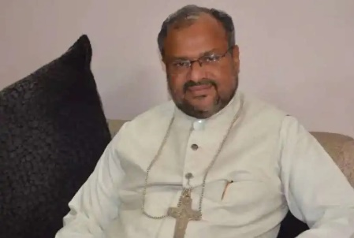
(1-6-23) The Vatican is investigating the transfer of $17 million from the Pontifical Mission Societies to a non-profit investment fund, the Associated Press has revealed.
The US-based Pontifical Mission Societies (PMS) raises money for papal charities. But $17 from that fund was transferred to Missio Corp., a private equity fund set up and administered by Father Andrew Small, who was director of the PMS. Missio Corp. then made low-interest loans to church-administered agricultural programs in developing countries. Although the transfers were legal and approved by the PMS board, the funds were not used for the stated purpose of the PMS: to support charities chosen by the Pontiff.
Indian bishop acquitted of rape resigns
(1-6-23) Pope Francis has accepted the resignation of Bishop Franco Mulakkal, 59, as bishop of Jullundur, India.
Appointed by Pope Francis in 2013, Bishop Mulakkal was arrested in 2018 on charges of raping a nun and stepped aside from his duties. He was acquitted in 2022 and met the Pope in February.
The Vatican removed Bishop Mulakkal from the administrative responsibilities of the diocese based in northern Punjab state just before police arrested him in 2018 on charges of raping a nun.
The nun, a member of the Missionaries of Jesus congregation, under the patronage of the bishop, accused him of raping her more than 13 times between 2014 and 2016 inside her convent in Kerala state’s Kottayam district. A district court acquitted Bishop Mulakkal. The court on Jan. 14, 2022, said the prosecution could not establish the police charges against the accused. Even after his arrest, the Vatican allowed Bishop Mulakkal to retain his title as bishop of Jalandhar and appointed an apostolic administrator in the diocese.
The apostolic nunciature in a June 1 statement said the resignation was requested from Bishop Mulakkal but it was not a disciplinary action and there are no canonical restrictions on his ministry.
Bishop Angelo Gracias, the apostolic administrator of Jalandhar in a message said with the resignation of Bishop Mulakkal, the diocese of Jalandhar "is now vacant."

At Marian shrines, Synod is entrusted to Blessed Virgin Mary’s intercession
(1-6-23) On May 31, the Feast the Visitation of the Blessed Virgin Mary, the upcoming assembly of the Synod of Bishops in October was entrusted to the Blessed Mother’s intercession at Marian shrines around the world.
The General Secretariat of the Synod had announced the initiative in March.
Pope points Latin American entrepreneurs toward ‘culture of encounter’
(1-6-23) Speaking on June 1 to members of the Latin American Business Council, Pope Francis said: “A culture of encounter expresses the search for the common good, and thus contributes to dispel shadows.”
Vatican - The mission, the work of God in our "vessels of clay". Cardinal Tagle addresses the Assembly of the Pontifical Mission Societies
(1-6-23) Every authentic apostolic mission is the work of Christ, who acts by grace and in the lives and hearts of his disciples, thus making himself "perceptible" to others. This was recalled by Cardinal Luis Antonio Tagle, speaking on May 31 during the first day of the General Assembly of the Pontifical Mission Societies, underway in Ciampino (Rome).
To the more than 100 national directors of the PMS, from all continents, the Pro-Prefect of the Dicastery for Evangelization proposed in an "off the cuff" speech, three simple points of reflection to accompany the work of the PMS Assembly, drawing inspiration from the Gospel story of the Visitation of Mary to Elizabeth, celebrated as a feast in the liturgy of the day at the close of the Marian month of May. God Himself intervenes in the life of Mary in view of a mission – a virgin becomes a mother. A treasure in the vessels of clay of which Saint Paul speaks. "A still hidden presence of the Redeemer was perceived by those – Elizabeth and John - who were filled with the Holy Spirit, which allowed them to perceive even what was not visible but present." Thirdly, the Visitation - continued the Cardinal - is an event of joy: John the Baptist rejoices in Elizabeth's womb, Elizabeth pronounces the words of joy repeated in the Ave Maria, and Mary herself prays with the "beautiful prayer" of the Magnificat, with which she praises the Lord.
Sudan - No "truce" really stops weapons. Bombings also block humanitarian aid
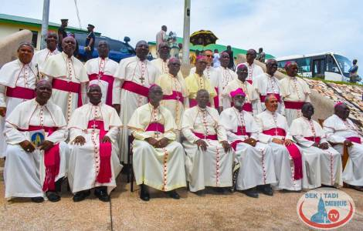
(1-6-23) The Sudanese army has suspended negotiations, under the aegis of the United States and Saudi Arabia, aimed at guaranteeing a truce that should have allowed the delivery of humanitarian aid in the country where famine threatens. The army accuses the paramilitaries of not respecting their commitments and is "ready to fight until victory", said General Bourhane, during a visit to his men in Khartoum.
Ghana - Resolve local conflicts to eliminate fertile ground for jihadist groups present on the borders
(1-6-23) Attention must be paid to terrorist threats from neighbouring states such as Burkina Faso, Togo and the Ivory Coast, as requested by the Ghana Bishops' Conference (GCBC).
The appeal was launched on May 31 by the President of the GCBC. Bishop Matthew Kwasi Gyamfi of Sunyani, during a regional dialogue session on the evolution of the conflicts in the Bono region, in Sunyani.
"Ghana is considered one of the most stable countries in West Africa, but the presence of latent conflicts, such as the one in the Bawku region, in the north, on the border with Burkina Faso
could offer fertile ground for the infiltration of jihadist groups present in neighboring states, offering support - fighters, weapons or training - to both sides as a way to win local allies for a future insurrection against the Accra government,” Bishop Gyamfi said.
South Korea - Dioceses and parishes committed to "carbon neutrality", in the spirit of Laudato Sì
(1-6-23) Faced with the global climate crisis, humanity faces the great task of so-called "carbon neutrality", defined in climatology as "the state of equilibrium between carbon dioxide (CO₂) emissions of anthropic origin and its removal from the atmosphere", that is. the condition of "zero net emissions" of CO₂. The issue does not leave the Catholic community in South Korea indifferent, which has taken Pope Francis' encyclical Laudato Sì seriously. For this reason, the Commission for the Environment and Ecology of the Bishops' Conference of South Korea is organizing a study day entitled "Carbon neutrality of the Korean Catholic Church" on June 5, organized by the Catholic diocese of Incheon.

Church cautions against polarization attempts in Sri Lanka
(1-6-23) Church leaders in Sri Lanka have cautioned people against politicians' attempts to divide people based on religion ahead of the presidential election next year.
“Racial and religious conflicts have been created to gain political power throughout history. It seems that the persecution of Buddhism is part of a conspiracy to gain power,” Father Cyril Gamini, media spokesman of the Archdiocese of Colombo said at a press conference on May 31.
The statement comes three days after police arrested Jayani Natasha Edirisuriya, a 31-year-old woman stand-up comedian for disrespecting Buddha and ridiculing Buddhist girls as virgins.
Earlier, President Ranil Wickremesinghe on May 15 announced a probe against Pastor Fernando, whose followers include famous cricketers, film stars and businessmen, for allegedly making derogatory statements about Buddha while addressing a gathering of members of his Born Again Christian church, which was broadcast live on social media.
Father Gamini warned that some parties may conspire to gain political power by exploiting such incidents and urged people to be vigilant and not to be misled.
Several civil society organizations also have expressed their opposition to the politicization of incidents like those involving the pastor and comedian.
UN special envoy for Myanmar to step down
(1-6-23) The United Nations special envoy for Myanmar will step down on June 12, a spokesman for the UN chief told AFP on May 31, after an 18-month tenure in which she was criticised by the junta and its opponents.
Myanmar has been in turmoil since the military seized power in February 2021, ending a brief democratic experiment and sparking clashes with ethnic rebel groups and anti-coup fighters.
Diplomatic efforts led by the UN and the Association of Southeast Asian Nations (ASEAN) bloc to resolve the crisis have so far failed to stem the bloodshed unleashed by the coup.
Noeleen Heyzer, who was named envoy by UN Secretary-General Antonio Guterres in October 2021, "will conclude her assignment on 12 June" when her contract ends, Stephane Dujarric said.
Heyzer, a Singaporean sociologist, was tasked with urging the Myanmar junta to engage in political dialogue with its opponents and end a bloody crackdown it launched after toppling the government of Aung San Suu Kyi.
2-6-23
South Africa - "Saint Scalabrini shows us the way of welcoming migrants and refugees"
(2-6-23) "Saint John the Baptist Scalabrini is a great model to whom we can turn in prayer, because he lived what we live as Church with migrants and refugees in South Africa", said Bishop Joseph Mary Kizito of Aliwal and person-in-charge for the pastoral care of migrants of the South African Catholic Bishop Conference (SACBC), in his message for the first celebration of the solemnity of St. John the Baptist Scalabrini, on June 1.
"Saint Scalabrini defended the human rights of migrants. That is why we are so grateful today to have a patron saint of migrants who can intercede for us...a defender of the poor ", remarked Bishop Kizito.
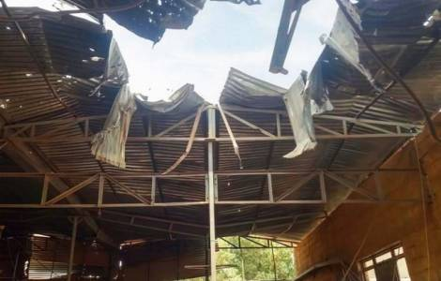
Sudan - Resumption of clashes: Missionaries remain on site
(2-6-23) The fighting in Khartoum has intensified and 18 people have died and 106 civilians have been wounded in clashes between air raids and heavy artillery in the middle of residential areas. This is confirmed by a statement from the Medical Committee. A World Food Program (WFP) official also reported that militiamen used military force to seize 20,000 tons of humanitarian supplies destined for the population of the city of Al-Ubayyid.
Despite the dangerous context, the Salesian missionaries have decided to stay close to the population in the capital and in El-Obeid.
Jailed Chinese activist urges fasting on Tiananmen anniversary
(2-6-23) A Chinese jailed rights activist has urged the people to observe a day of fasting on June 4 in remembrance of the victims of the 1989 Tiananmen crackdown.
In a letter from prison, Xu Zhiyong, a Chinese jailed rights activist, has urged his supporters to fast on June 4 in remembrance of the victims of the 1989 Tiananmen crackdown but also warned them of retaliation from the government, Radio Free Asia reported on June 1.
The letter was published by the Rights Protection Network website and the Twitter account of US-based activist Teng Biao. "I may fall silent for some time after this," Zu said hinting at possible retaliation for his letter to the public.
Outrage in Pakistan over rights activist’s abduction
(2-6-23) Christians and human rights campaigners have condemned the alleged abduction of an outspoken rights activist who is known for his support of religious minorities in Muslim-majority Pakistan.
Lawyer, politician, and rights activist Jibran Nasir was picked up by unidentified armed men from near his residence in the southern port city of Karachi on June 1, his family members claimed.

Bishops seek end to Christian persecution in Indian state
(2-6-23) The national body of Indian Catholic bishops has expressed concern over the filing of criminal cases against a bishop, priests, nuns, and laypeople in the central state of Madhya Pradesh.
The Catholic Bishops’ Conference of India (CBCI) in a May 31 statement said it was “deeply saddened” by recent attacks on Christians and their institutions, especially in Jabalpur diocese where Bishop Gerald Almeida and his community were being targeted by federal and state child rights panels.
The CBCI pointed to surprise inspections of Church-run schools, hostels and orphanages and the filing of criminal cases alleging religious conversion, sexual abuse of children, fraud, and other offenses, and called for an end to the harassment of Christians and their institutions in Madhya Pradesh
“The bogey of religious conversion which has no basis is brought up to tarnish the selfless and dedicated services of thousands of priests, religious and lay people,” CBCI secretary-general, Archbishop Felix Anthony Machado, said.
Bishop Almeida has been named in two cases of alleged religious conversion and fraud. The latest case was registered against him on May 30 after a surprise inspection at an orphanage run by the diocese for children rescued from railway stations in Katni district. In an earlier unfounded fraud-case on March 22 he was given a temporary bail.
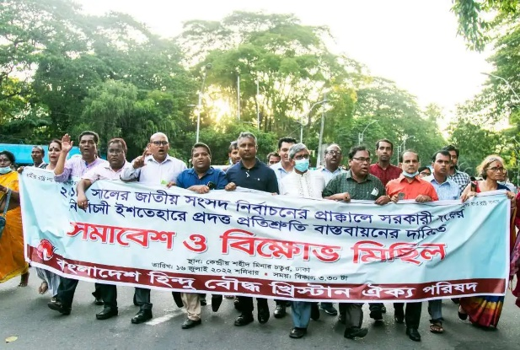
Bangladesh minorities fear violence upsurge ahead of polls
(2-6-23) The minority community in Muslim-majority Bangladesh fears that violence will increase against minorities ahead forthcoming polls in January due to non-fulfilment of poll promises by the ruling party.
Despite our repeated demands, poll promises made by the ruling Awami League “in the 2018 election manifesto have not been fulfilled,” ‍Hemanta Corraya, secretary of the Bangladesh Christian Association (BCA), told UCA News.
Judicial probe into ethnic violence in Indian state
(2-6-23) India’s federal home ministry has ordered a judicial probe into the unprecedented ethnic violence in a northeastern state that claimed over 70 lives and displaced thousands of people.
The judicial commission, Federal Home Minister Amit Shah said on June 1, “would investigate the cause of the violence and identify those responsible for it.”
On the last day of his four-day visit to strife-torn Manipur state, Shah warned of stringent action against those who were behind the violence.
Shah announced the setting up of a peace committee and an inter-agency unified command for better coordination between security forces amid fresh reports of violence in the state.
Violence in the state started on May 3 when the Kuki tribal community, majority of whom are Christians, began a protest against a court decision granting the Scheduled Tribe (ST) status to the Meitei community, who are mostly Hindus and not so poor.
The ST status comes with reservations in jobs and education under India’s affirmative action plan. The Christian-majority Kuki community’s leaders asked Shah to impose President’s rule in the state as they had lost faith in Chief Minister N Biren Singh-led government.
7 Indian pastors get bail in 'conversion' case
(2-6-23) Seven pastors jailed in separate cases under the draconian anti-conversion law in the pro-Hindu Bhraratiya Janata Party ruled north Indian state of Uttar Pradesh have been granted bail after intervention by the Supreme Court in Delhi.
Courts have also granted bail to 12 others in the past two weeks to take the total number of Christians securing bail to 19 after spending months in jails.
3-6-23
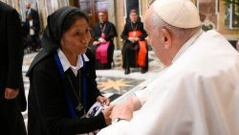
Vatican - Pope Francis to the Pontifical Mission Societies: the mission flourishes from the heart of Christ and from the "disorder" of the Holy Spirit
(3-6-23) The mission of the Church in the world has its "heart" and its source in the very heart of Jesus. Missionary spirit "is not a natural thing", is born in "Whoever lets himself be attracted by the love of Christ" and feels "the desire to bring to all the mercy and compassion that flow from his Heart". And to unleash the impetus of the mission "It was necessary for the Holy Spirit to come and make that terrible 'mess' that was the morning of Pentecost". With these evocative images, Pope Francis recalled on June 3 as well what is the source of grace from which every authentic apostolic work can spring. He did so by receiving in audience the participants in the annual general assembly of the Pontifical Mission Societies (PMS), underway in Ciampino (Rome). more than 110 national directors of the PMS network, from all continents, took part in the Audience, in the Clementine Hall of the Apostolic Palace, accompanied by Cardinal Luis Antonio Tagle, Pro-Prefect of the Dicastery for Evangelization, among others. The Holy Spirit "to create missionary spirit, to create the life of the Church", the Pope remarked, "creates disorder, but then creates harmony. Both things are of the Holy Spirit."
Vatican - In martyrdom, love for Jesus overcomes fear. Cardinal Tagle remembers the Holy Martyrs of Uganda
(3-5-23) "Suffering in itself is not martyrdom, suffering becomes martyrdom when there is testimony". This was underlined by Cardinal Luis Antonio Tagle, Pro-Prefect of the Dicastery for Evangelization, during the Eucharistic celebration in St. Peter's Basilica held on June 3 morning immediately after the audience with the Pope of the participants in the General Assembly of the Pontifical Mission Societies (POM) in progress these days. The Cardinal exhorted the directors of the POMs to "feed" on the reflection of the words heard shortly earlier from the Pontiff for the mission, and continued the homily by dwelling on the very nature of martyrdom, starting from the day's liturgical memory of martyrs of Uganda.
“Today we celebrate the memory of St. Charles Lwanga and his 21 companions, who converted to Christianity; they chose to follow Jesus, above all Jesus and only Jesus. The price of this faith was martyrdom. “Martyría” really means bearing witness", the Cardinal highlighted. Our martyrs were ready to die for bearing witness. Death is the final act and it is the best act for bearing witness; but we are called to bear witness to Jesus every day of our lives. We know well that to bear witness to Jesus we must die to ourselves. In bearing witness, death is necessary".
Cardinal Tagle clarified: “It is not death for something, it is rather a love but for someone who loved us until his death,” said Cardinal Tagle.
4-6-23
Pope at Angelus: The Sign of the Cross makes us feel God's embrace
(4-6-23) The sign of the cross reminds us how much God loves us, Pope Francis underscored during his Angelus address Sunday at noon on the Solemnity of the Most Holy Trinity.
Addressing the thousands of faithful in St. Peter's Square, before reciting the midday prayer, the Pope said that the simple gesture, that we learn as children, makes us feel God's embrace, that, with His Love and tenderness, envelops us completely.
Referring to the Gospel of the day, the Pope recalled, that Jesus said to Nicodemus, a member of the Sanhedrin, that God loved humanity so much that He sent His Son into the world. Jesus, he reiterated, spoke about His Father and His immense love. The concept of a Father and a Son, he said, "brings us back home." "Father, Son and Holy Spirit speak to us of a communion," he said. This is a reality because the Holy Spirit, the Spirit that the Father poured into our hearts through Jesus, makes us taste, makes us savour God’s presence: a presence that is always close, compassionate and tender."
The Holy Spirit does with us what Jesus does with Nicodemus, namely He introduces us to the mystery of new birth and reveals the heart of the Father to us, making us sharers in the very life of God.
“And do you know how we can remember this? With the simplest gesture, which we learnt as children: the sign of the cross.” "By tracing the cross," the Holy Father recalled, "we remind ourselves how much God loved us, to the point of giving His life for us; and we repeat to ourselves that His love envelops us completely, from top to bottom, from left to right, like an embrace that never abandons us." By making the sign of the Cross, the Pope noted, we also commit ourselves to bearing witness to God-as-love, creating communion in His name. The Pope noted that offering love, involves being merciful, keeping the door open, and making our communities a home for all.
Pope remembers the victims of train accident in India and of war
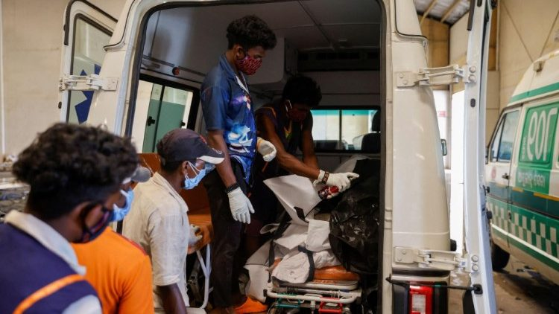
(4-6-23) After the Angelus prayer, Pope Francis remembered the victims of the train accident in India on Friday June2 that took the lives of more than 300 people and injured some 1,200 others, according to recent reports. In the collision, three trains were involved.
The Pope assured them of his prayers and said that he is close to the injured and their families.
The crash involved a speeding passenger train that ended being directed on to a secondary track where it collided head on with a parked freight train. The massive impact affected a second speeding train passing in the opposite direction knocking against the derailed compartments lying on the track. Investigations are underway and there are reports the cause may be related to a faulty rail switch.
The Pope then offered his prayers for the victims of the scourge of war, remembering especially the suffering people of Ukraine.
---------------------------------------------------------------------------------------------------------------------------------------

